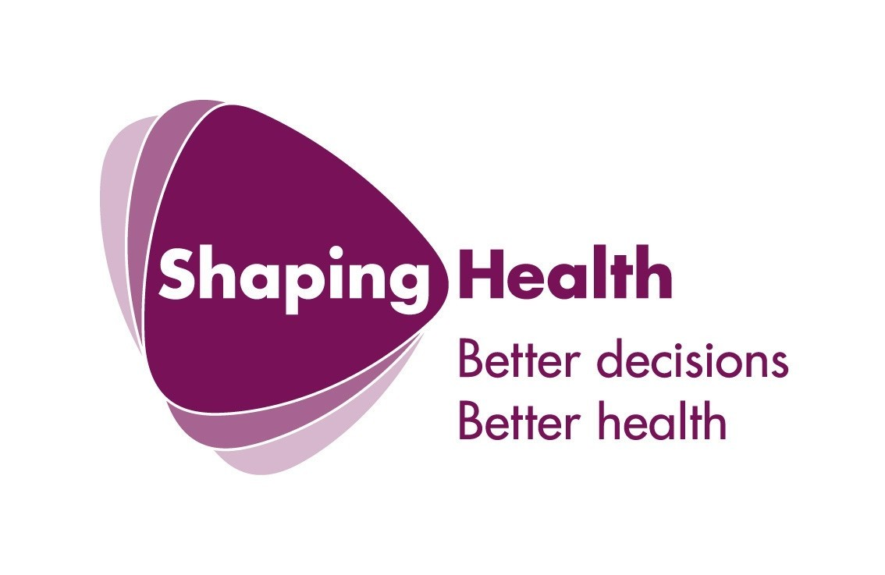

‘Unheard voices’: listening to Refugees and Asylum seekers in the planning and delivery of mental health service provision in London.

A research audit on mental health needs and mental health provision for refugees and asylum seekers undertaken for the Commission for Public Patient Involvement on Health (CPPIH).

Researched and written by David Palmer & Kim Ward

Summary

1. London Region Commission for Patient and Public Involvement in Health (CPPIH) commissioned research in 2004/2005 into the mental health needs of asylum seekers and refugees on behalf of the London wide network of Mental Health Patient and Public Involvement Forums. The research found a general lack of awareness in the NHS of the distinct needs of asylum seekers and refugees although some clear examples of good practice were highlighted.

2. CPPIH commissioned further research in 2005/006 and the development of best practice guide for service commissioners and providers. This guide is intended for use by a wide range of stakeholders. The guide will be useful for health commissioners and providers, service users, local authorities and other key statutory and voluntary agencies in the development of inclusive, evidence based services that meet the needs refugees and asylum seekers. Specifically, it is intended to be a reference in order to gain an understanding of the mental health needs of this group and an aid to the development of strategies to improve well-being. The guide is organised in three parts. Parts One and Two set out the context of the research, the findings of the research and the methodology used. A key feature of the research and the best practice guide is that it has been undertaken from a service user perspective. Interviews were conducted with 21 acutal or potential service users from the asylum seeking and refugee community.

3. This research indicates that all professionals involved in the planning, delivery and funding of services need to acknowledge the range of problems and issues experienced by those living in exile. By taking a wide perspective of mental health needs, commissioners and providers can plan intervention, which takes account of the multitude of practical, social, cultural, economic and legal difficulties, which can act as contributing factors to the long-term mental health of refugees and asylum seekers. The fundamental challenges faced by service commissioners and providers in the mental health and social care sector is to incorporate the views, and whenever possible the users themselves, in the planning and delivery of services.

4. One of the most significant themes to emerge from our research has been the need for a holistic way of working with Refugees and Asylum seekers with mental health care needs. The implications for such a method of working are far-reaching, moving beyond a medical model of the causes and effects of ill health. The alternative is a social model which acknowledges the social, political and cultural constructed definitions and arrangements/experiences that determine an individual’s expectations, knowledge and circumstances. It therefore follows that health is a holistic concept embracing an individuals social, physical and mental well-being and influenced by social, economic, political and environmental experiences. In this way the solving of mental health ‘problems’ becomes an issue beyond that of the individual, rather encompassing the challenge of working with the organisation of key aspects of social life (to include housing, employment, legal status, education and training).

5. This produces challenges at all levels - from strategic, to operational planning, to service delivery. Providing holistic care can be difficult to co-ordinate across many disparate services. A truly holistic approach would also need to involve social services, refugee, voluntary and community organisations, mental health providers and a range of providers in the both the voluntary and statutory sector.

6. Ultimately the aim would be for adequate long term funding being available to refugee self-help, community, faith groups and voluntary sector organisations in order for them to deliver local services to local communities. Treatment and service options would therefore be more easily controlled and chosen in accordance with the context of refugee lives and therefore the actual needs and choices of the individual refugee. This approach is a truly radical re-organisation potentially encompassing changes not only in healthcare but in welfare, housing, employment and immigration policy. Local community groups, ideally managed by committees containing members with first-hand experiences of the pre and post migratory realities as well as experience or knowledge of the mental health system, are well placed when compared to large monolithic government organisations to understand and meet local refugee needs, offering and delivering alternative and more appropriate options.

We have drawn out emerging themes, priorities and implications from the interviews carried out with all participants. Many of these themes overlap and are linked on significant points and significantly with the subsequent recommendations. We have therefore negotiated this complex issue and identified six main areas for consideration, these are:

- Partnership working – statutory, Refugee and voluntary sector community groups: Addressing social care needs by working holistically – combating social, economic and political factors
- Accessibility and engagement – Advocacy, befriending, and user participation in service planning and delivery
- Cultural sensitivity and understanding – perception, stigma, language, education and training
- Care provision – Talking therapies, alternative therapies, user-led services and possible solutions
- Evaluation, consultation and planning/funding future services

Key recommendations – relevant to all areas:

Health providers need to offer a ‘holistic’ response to the needs of refugees, providing advice and advocacy, social and emotional support, and access to education and training.

Promote and fund ‘One stop shop’ services. Such multi-agency services can provide comprehensive advice and support dealing with the multi-faceted needs of the refugee and asylum seeker communities. This model facilitates partnership working, improving communication between organisations and providing a service base which aims to be all-inclusive and adopting preventative measures thus improving health outcomes.

Partnership working – statutory, Refugee and voluntary sector community groups: Addressing social care needs by working holistically – combating social, economic and political factors

Partnership working

recommendations

- Recognition, support and investment in incorporating Refugee community and voluntary organisations into the development and implementation of mental healthcare provision for refugees and asylum seekers. These organisations have the expertise, specific knowledge and experience to contribute at a strategic level such as planning and design and additionally they need to be strategically supported to provide and develop the services that they offer.

- Many support services are voluntary projects which survive on short-term or little funding. While this may be appropriate when services start, it is important that local authorities and government departments look to 'mainstream' services and funding to allow them to be more widely and more permanently available.

- Capitalising on community knowledges and understandings in terms of building on existent projects and ideas. This can be achieved through formal consultation structures and informal networks (such as newsletters and cultural events).

- ‘Signposting’ – ensuring that service users are directed to other services available to them in both the voluntary and statutory sectors.

- Information sharing between partners providing specific and relevant details and resources in order to meet health and social care needs.

- NHS Trusts and the PCT should be pro-active and liaise with Refugee community and voluntary organisations in order to raise awareness on particular and relevant available services.

- It is necessary for those commissioning and planning services to be clear of the specific needs of refugees and asylum seekers. There is a need to develop clear commissioning protocols that promote co-ordinated care.

- Processes need to be flexible to recognise local needs and to identify agencies and Refugee and voluntary community groups that are best placed to provide services in a given area. For these communities to be effectively integrated this expertise must also be integrated into mainstream discussions on issues affecting the lives of asylum seekers and refugee communities.

- Commissioners need to sustain involvement of Refugee, voluntary and community organisations at planning and service delivery level by encouraging the formation of regional and local networks and partnerships.

Addressing social care needs by working holistically

Housing

Recommendations:

- Planning the supply of housing needs, including NASS accommodation in LONDON, needs to be based on extensive consultation in order to ensure that it meets the needs of local refugee communities.

- Stronger partnership working between housing organisations and Refugee community organisations (R.C.O’s) should lead to more culturally-sensitive services, related more closely to people's needs. R.C.O’s are keen to be involved in influencing and in some cases providing support services.

- Housing departments, support teams and refugee communities should work in close partnership to help refugees settle and sustain independent living.

- Housing providers including NASS must establish a effective protocols and a regular method of inspecting accommodation, emergency, temporary and long-term, to ensure that accommodation providers are meeting adequate standards in terms of amenities and environmental health standard.

- Some refugees may prefer to be accommodated in an area hugely populated by their own community where services are geared to address their distinct cultural needs.

- Local authorities should seek to keep ‘out of Borough’ placements to a minimum and carefully assess the potential risks associated with placing individuals away from their community and support networks.

- Some refugees may have mental health needs that require specific care and should therefore have access to specific support services. There is a need to develop housing stock, which accounts for specific requirements.

- Refugees and asylum seekers with a disability should be allocated to suitable and where appropriate supported accommodation.

- The use of temporary accommodation for refugees and asylum seekers should be kept to a minimum.

- Partnership services need to organise to provide extensive support to enable users to move quickly from temporary to secure permanent accommodation.

- It is essential that local authorities provide assistance to those moving from temporary to permanent accommodation. Given that some may have difficulties with the English language, are not familiar with the welfare benefit system, may have few family members or friends in the UK, may be fearful of racist attacks and are generally a vulnerable group more attention and expertise needs to be devoted to helping refugees settle into their new residencies.

Sustainable living

Recommendations

- A ‘One stop shop’ model is again extremely relevant to solution planning in this area. Such a model would help facilitate income maximisation on many different levels to include negotiating the welfare system, education, training and careers advice.

- Minimising the number of contacts users need to have with the benefit system in order to secure the right outcome.

- Awareness training for professionals on the importance of securing entitlements and recognising need and referring users on to appropriate sources of help.

- Systems and processes to ensure equality of access and provision, for example - access to a home visiting service for especially vulnerable refugees, to ensure that they are not lost or forgotten or excluded from mainstream support systems.

- Improving public awareness of entitlements and availability of support – advertising campaigns and benefit checks focused on specific entitlements for specific communities.

- Improving forms and leaflets, less jargon, multi-language formats and a simpler application process.

- Refine the process of those moving from NASS support to mainstream welfare support.

- Financial assistance for those who are destitute refused asylum or outside immigration rules.

Legal, Political and Institutional factors

recommendations

- Training needs to be provided for all relevant parties working with refugees and asylum seekers to ensure that they are able to face the challenge of understanding and adapting to the frequent changes in current legislation and policy.

- Improving the immigration process so that claims are decided equitably and as fast as possible, therefore mitigating against anxiety, fear, demoralisation and destitution.

- Refugee and Asylum seeker organisations both voluntary and statutory need to expand their remit in terms of acting as pressure groups lobbying the Government, particularly the Department of Health, NASS and the Home Office to improve policy related to refugees and asylum seekers.

- NASS administrative systems should be expanded and improved in order to avoid the numerous delays and failures in payments that currently occur.

- NASS to work with health care professionals and communities to ensure continuation of care is provided and consequently not to disperse those with mental health care needs and thus disrupt their vital care and support provisions.

- Permission to work immediately should be granted to those who have submitted and application for asylum in order to give the opportunity to support themselves and not remain dependent on state support.

- The UK Government should be pro-active in educating health provider and the public so they have a full and accurate understanding of the reasons why people claim asylum in the UK and the actual level of state support to which they are entitled. In this way, discrimination and hostility can be reduced, and the public support for providing adequate levels of assistance can be improved.

Cultural sensitivity and understanding – perception, stigma, language, education and training

recommendations

Cultural sensitivity and understanding
- Agencies need to address the lack of cultural understanding of the dynamics of refugee communities and the cultural, political and social background of refugees. Relationships need to be developed between Refugee, voluntary, faith and community organisations and mainstream agencies, developing good practice standards for wide implementation, such as always providing refugee clients with appropriate advocates

- Services need to work in partnership with refugee and asylum seeker community groups and voluntary organisations to ensure that the services provided are responsive to the client group.

- Innovative approaches need to be employed to empower communities such as through the ‘Refugee Doctors programme’ a national initiative, whereby refugee doctors are encouraged and supported to resume their medical careers in the UK and work towards developing culturally appropriate services within mainstream provision. Such programmes can act as a forum in which individuals and organisations can exchange information, share experiences and work on specific health projects with members of their community. These events can also highlight issues and gaps in service provision for which lobbying is needed.

- Service providers need to ensure equal opportunities for BME individuals to be represented in the workforce, thus making services more culturally competent.

Stigma
- In order to combat stigma there needs to be a multi level community education and training process where members of the community provide positive role models and demonstrate the possibility of positive outcomes and counter the possible negative beliefs within the community and institutions which stigmatise those suffering from mental ill health.

- To reduce stigma surrounding mental illness, strategies need to be multi-faceted and have a co-ordinated approach to ensure that they reach community members, individuals and institutions.

Language
- Partnership work between public, private and community groups needs to be developed in order to combat the difficulties related to linguistic and interpretation needs. For instance community organisations have access to interpreters who are able to represent the needs and desires of the individual refugee within a user participation forum or at a service provision level.

- Funding is required for Refugee, voluntary and community organisations to provide training programmes for refugees to act as paid interpreters or translators for their own communities, empowering them to help others and potentially address the issue of trust if the interpreters themselves have had experiences and understanding of mental distress.

- The NHS needs to ensure the availability of appropriate trained interpreting and advocacy services. Ideally access to a consistent interpreter would allow for the building of trust.

- It is important that service users have access to a choice of interpreter, one perhaps not from their own culture, if they do don’t feel comfortable or secure with an interpreter they are unlikely to be open about their situation.

- Service providers must ensure the availability of a range of health promotion literature/information that is aimed at refugees and asylum seekers in relevant languages and culturally sensitive.

- Health providers need to develop a system of translating letters, forms and appointment cards into relevant languages and formats.

- Health providers should have targeted written/video information in community languages produced in partnership with Refugee, voluntary and community organisations on health service provision and steps on accessing these services.

Education and Training
- Health providers need share information about education and training opportunities available to asylum seekers and refugees.

- Access to Learner Support Funds and other funding streams for asylum seekers and refugees is necessary to increase participation and retention on education and training programmes.

- Refugee, voluntary and community organisations need to be adequately funded and supported to allow them to provide good quality ESOL classes that are differentiated and specialised to maximise opportunities for progression, and IT class, and creative classes such as storytelling and developing self-esteem/confidence building classes.

- Health providers need to conduct education programmes at a community level, ensuring that users are informed about accessing services and where to access information and treatment options.

- Health providers and commissioners need to ensure effective training in trans-cultural awareness for mental health professionals and community groups. This would need to include information and training on ethnicity and mental health which should cover understanding of language, culture and racism and the implications on mental health service provision. Ideally, training would be built into qualifying courses and continue throughout a professional career.

- All NASS staff dealing with applications for support should receive awareness training on relevant issues including mental health and disability.

- Training needs to recognise the importance of health awareness programmes that focus on mental health issues.

- Staff in community groups would need specific training so that they were able to recognise the symptoms of mental ill-health and importantly to work with refugees in a supportive environment to combat any negative attitudes and stigma associated with mental illness.

- Refugee Community organisations must be consulted and involved in the delivery of education and training programmes to communities and individuals that they have a professional expertise of working with.

- Refugee and Asylum seekers organisations, voluntary and community organisations need to be aware of the different career pathways available to their service users, and link with local education and training centres to improve access to appropriate courses; in addition to liaising with The National Academic Recognition Information Centre so that correct advice can be given on the comparability of overseas qualifications.

- Health Authorities should play a more active role in assisting conversion training for refugee mental health professionals (e.g. for people who are doctors in their country of origin).

Care provision – Talking therapies, alternative therapies, user-led services and possible solutions

recommendations

- It is essential for health providers to work at a client-based level, exploring the individual understandings and specific beliefs relating to mental ‘illness’ and to address and incorporate where possible issues which they believe will be relevant to their mental health and that will promote their wellbeing

- Strategies should be in place to recruit qualified and ethnically diverse staff at all levels, and services need to liaise with religious, faith and community leaders in order to understand all the possible treatments being undertaken and what they regard as effective interventions.

- Care providers can learn from or incorporate coping mechanisms that may have been used in the country of origin, in this way the best elements of both Western and indigenous methods and techniques can be combined to provide the most appropriate care package.

- Treatment options need to be broad and flexible in order to adapt to the specific needs of individual users. This will mean a variety of options are available when necessary throughout a course of treatment, one approach may be used to complement another (e.g. medication with talking therapies, or talking therapies with homeopathy) or a completely different course of treatment opted for on its own. This would require an exploration of alternative therapies and traditional treatments such as meditation, massage, aromatherapy, homeopathy, herbalism and acupuncture, and the securing of funding for such provision

- Care packages need to respond to, and attempt to overcome the potential barriers in accessing services, for example to help overcome stigma and isolation, language specific telephone support, outreach strategies, clinics and information sessions in community settings should be provided to promote wellbeing.

- Services should be welcoming and include information which is user friendly and available in community languages.

- Services should be developed in consultation with refugee, community and voluntary groups and where possible users should be encouraged to participate in the design and planning in order to establish effective access and provision.

- Health providers need to promote a culture in which users are encouraged to participate fully in their care plan and evaluate the services they receive.

- User- led services such as sewing, music; creative writing and art groups should be funded in order to improve access, health promotion and user-initiated interactions

- Services should use innovative approaches to reach isolated refugees and asylum seekers such as and cultural events, coffee mornings, relaxation and stress management classes.

- Service providers should undertake outreach work to develop links and establish trust with community groups. This would enable both professional and non-professional community members to be involved in supporting users who are experiencing emotional difficulties.

Evaluation, consultation and planning/funding future services

recommendations

Evaluation, consultation and planning
- Mechanisms should be in place to incorporate user feedback into services. These mechanisms need to allow for innovative ways of engaging with users that may be less formal than traditional forms of consultation; engagement is therefore on the users’ terms rather than through a pre-set format and consequently more likely to encourage participation (see recommendations for user involvement for possible suggestions).

- Ensure that refugee, faith, voluntary and community organisations are effectively involved in the commissioning, planning and delivery of services.

- The evaluation process for service providers needs to be regular and thorough, with specific consideration of the refugee and asylum seeker user. A good evaluation process should include the following:

  - feedback from service users, community groups, carers and families
  - confirm that the service is effective and meets the needs and wishes of the service user
  - review language provision and bi-lingual needs including ethno-specific counselling
  - collect and maintain accurate and detailed ethnic monitoring in both primary and secondary care
  - incorporate recommendations for service improvement based on the information obtained
  - service providers should encourage independent and external evaluation.

- Working with refugees and asylum seekers with mental health care needs is both complex and intensive staff should therefore receive regular supervision, positive and constructive feedback, and adequate non-contact time.

Funding
- Local Authorities, including primary care trusts need to work in partnership as part of the Local Strategic Partnership’s (LSP’s) to develop a more comprehensive, long-term approach to funding services for refugees and asylum seekers.

- Local Government Authorities need to provide capacity building, training and practical assistance for refugee, voluntary and community organisations with funding applications and finding sources of funding (e.g. from both statutory and charitable sources.).

- Innovative support services and projects need to be funded in order to provide a wide range of care provision and support and all those working with and caring for those with mental health needs. This is also to include support for family members and friends, such as drop-in sessions, access to information and advice and a therapeutic space for both users and their families to give and receive support.

Mental health provision for asylum seekers detained in Immigration Detention Centres (IDC’s)

recommendations

- The responsibility for medical care of detainees should be transferred from the Home Office to the NHS. This would mean that:
  - All healthcare provision accessed by detainees would be registered, regulated and inspected by the Healthcare Commission;
  - Patient and Public Involvement Forums would have the legal right to monitor the provision of healthcare in IDC’s;
  - Detainees would have rights of redress through the NHS complaints procedure if they had concerns about their care or treatment or access to care;
  - Detainees would be able to access the Independent Complaints Advocacy Service which supports people who have concerns or complaints about their health care.

- Detainees should have the right to access doctor of their choice, rather than have one imposed by the IDC.

- The Operation Enforcement Manual policies that apply to vulnerable individuals, such as children, torture survivors and people with severe mental health problems, that state that they should not “ordinarily be detained” should be rigorously complied with.

