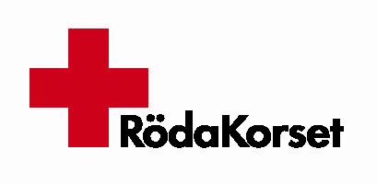
European Open Forum on Return

A Conference on voluntary return of rejected Asylum seekers in Europe
24th – 25th March 2006
Malmö, Sweden


Dear Madam and sir
Dear colleagues

Swedish Red Cross and its project partners are pleased to invite your organization to a European Open Forum on Return Conference to be held in Malmö – Sweden during 24th – 25th March 2006.

This Forum is to ensure transnational exchange, transfer and share of best practices aiming at furthering capacity building for and between all target actors and practitioners involved in voluntary return.

The aim of the forum is to facilitate exchanges of experience.

Stakeholders involved in current, past or future project on voluntary return is the main target group. The forum is also expected to attract members of the European Commission involved in European return policy.

The conference will be chaired by the president of the Swedish Red Cross. Key speaker include but not limited to Minister of Migration (Sweden) and the European Commission. Representatives from UNHCR, IOM, ECRE, Red Cross Societies, NGOs and National Migration Authorities across Europe will participate in the conference. A number of thematical workshops will run during the conference.

Registration
The project website offers an exceptional opportunity for participants to register on-line by logging on to the project website www.returnforum.net –contact-online registration. Participants can also e-mail their registration to either lena.kjellquist@redcross.se

Additional option for registration is to complete application form and fax it to +46 40 32 65 01 with attention Lena Kjellquist.

Conference Rates/Conference fee

The Conference fee is EUR 250 and will cover all, materials, accommodation (for two nights) as well as meals during the conference.

Travels expenses up to EUR 500 will be refunded for participants from EU Member States participating in the ERF.

We, the project staff are pleased to welcome you all to Malmö – Sweden. Due to limited space it is important to send your application by 15th February 2006. Confirmation and further information will be sent to participants thereafter.

Yours sincerely
SWEDISH RED CROS

Mohamed Hirsi,
Project coordinator

Swedish Red Cross
International Law and Refugee Department
Box 7079
SE-200 42 Malmö
S w e d e n

