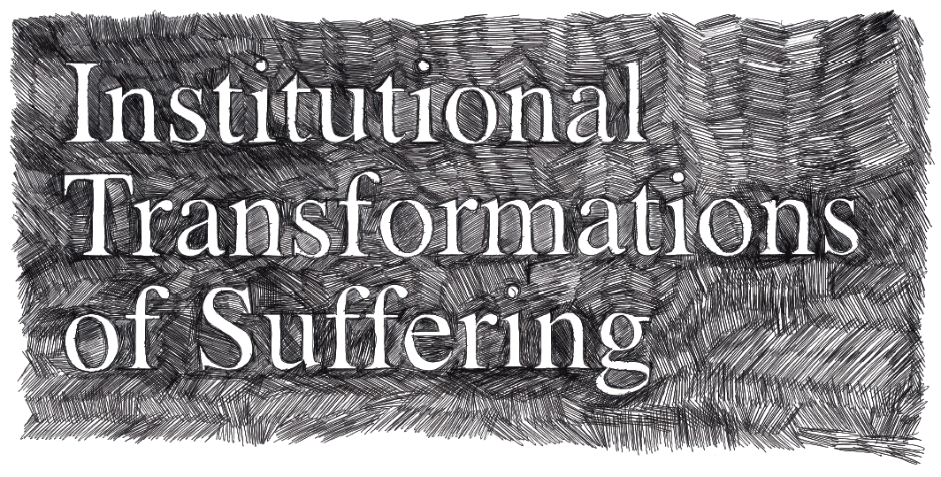

INTERNATIONAL CONFERENCE IN STOCKHOLM 8-11 NOVEMBER
A meeting between scholars and practitioners around the idea of social suffering and its institutional transformations

KEYNOTE SPEAKERS

Professor Jeanne Gaaker, Dept of Law, Erasmus University

Professor Arthur Kleinman, Dept. of Social Anthropology, Harvard University
Professor Iain Wilkinson, School of Social Policy, Sociology and Social Research, University of Kent at Canterbury

The Humanities and the Social sciences have a long tradition of dealing with human suffering, trying to understand how subjective experiences of individuals and collectives are connected with social conditions which cause or aggravate suffering. The aim of this conference is to deepen our understanding of social suffering by focusing on attitudes to suffering within different institutions and professional practices, such as medical care, psychiatry, migration politics and legal system.

The questions to be asked include:

- On what grounds do professional caretakers and others approach human suffering in healthcare?
- How do responsible authorities regard social suffering when people seek asylum in Sweden?
- How does the legal system deal with and understand social suffering in the encounter between the perpetrator and the victim?

These and other questions will be discussed during this three-day conference. The aim is to bring together Swedish and international researchers in fields such as Communication and Media, Ethnology, Law, Literature, Social Anthropology and Sociology, with people whose everyday work involves dealing with human suffering. We hope that the conference will not only be a forum for exchange of experiences, but that it will also offer a possibility to deepen our insights in the causes of social suffering.

Participation in the conference is free.
If you are interested, please mail before 27/10: jakob.nilsson@mail.film.su.se

Further information about the conference including preliminary programme is availaible on the conference website: www.nada.kth.se/media/Research/Transformations_of_suffering

The conference is jointly organized by the Dept. of Social Anthropology, Stockholm University, the Dept. of Ethnology, Stockholm University, and the School of Computer Science and Communication, Royal Institute of Technology. The conference is sponsored by the Swedish Science Council and by the Henrik Granholm Foundation.

Convenors:
Leif Dahlberg, dahlberg@csc.kth.se
Georg Drakos, georg.drakos@etnologi.su.se
Galina Lindquist, galina.lindquist@socant.su.se

