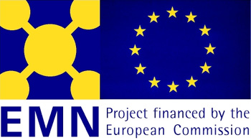


European Migration Network

Draft Programme

National EMN Meeting

Monday, December 11, 2006

09:30 – 10:00 Coffee

10:00 Opening and welcome, Ms Anna Wilen, Director of Population and Welfare Department, Statistics Sweden.

10:15 General overview of the Swedish Contact Point for EMN, organisation and activities during preparatory phase, Anna Eriksson, Statistics Sweden.

10:30 EMN and the future, Mr. Stephen Davies, DG Justice, Freedom and Security.
11:00 Views on EMN, Ms Sofia Heine, Swedish Ministry for Foreign Affairs.

11:30 Presentation of Estonian NCP

12:00-13:00 LUNCH

13:00 EMN reports; small scale studies I, II and III, Policy and statistical reports.

13:30 Research study III Return, presentation of national report, Anna Jonsson, Uppsala University

14:00 Coffee and Demo of EMN database

14:30 Tema Asyl within the Equal program, partner in EMN network

15:00 Statistics Sweden, population and migration statistics

15:30 Discussion on information needs and future role of EMN

16:00 End

