Association of Eritrean Asylum Seekers in Sweden-AEASS.

A unique experience in human rights advocacy and empowerment of asylum seekers.

By: Ginbot Abraha, founding member
and former Chairman of AEASS.

Stockholm, July. 2006

Table of Contents

Introduction 1

Background to the establishment of AEASS 3

Objectives of AEASS 6

Achievements 19

Challenges 24

AEASS transforms into EDHR 26

Conclusion and remarks 28

Bibliography 31

Dedication

This work is dedicated to Humanity and to all individuals and organizations
working to defend and promote it.

Introduction

Eritrea, the youngest state in Africa, once was hoped to be a model for success to be followed by many ‘failed states’ on the continent. This hope originated from the long and challenging years the Eritrean people went through for their independence and the high discipline, organization and commitment the Liberation Movement had shown for the national cause. However, as was the case with other liberation movements on the continent and elsewhere, the so called ‘nationalist leaders’, after achieving independence turned their backs on their people. Not long after assuming power, the new rulers, Eritrean People’s Liberation Front - Peoples Front for Democracy and Justice (PFDJ) of today- did everything in their power to deny the nation any political participation and to maintain its terror based authoritarian rule. After the out-break of the recent border conflict with Ethiopia (June 1988-May 2000) the situation reached its peak when the government violently cracked down on a peaceful reform movement and carried-out wide arrests among high government officials, journalists and ordinary citizens. These serious developments, which uncovered the true nature of the ruling authoritarian regime, thus resulted in adding our new state to the old list of failed states in Africa and made it one of the top human rights violators in the world. As a result, Eritrea today is the only country in Sub-Saharan Africa which lacks free and independent press and the largest prison for journalists on the continent. Eritrea, though has a constitution ratified in 1997 but is today (dys) functioning in the absence of a constitution. Consequently, absence of rule of law, human rights violations and state sponsored terror have become the norm in the country forcing thousands of Eritreans from all walks of life to flee the country in search of search
of freedom and protection in different parts of the world. According to the UNHCR in 2003 alone, 4402 Eritreans sought asylum in Europe and North
America with 641 of them being in Sweden. And according to the Swedish Migration Board, 1.878 Eritreans sought asylum in Sweden between 2001 and 2005. This big number of asylum seekers from a small country like Eritrea coupled with the high rates of negative decisions made on their asylum applications and the negative consequences they experienced due to prolonged waiting periods, triggered the establishment of Association of Eritrean asylum seekers in Sweden to raise awareness, advocate for asylum rights, and to empower and enable Eritrean asylum seekers to make sense of their life during the waiting period.

Background to the establishment of AEASS.

Prior to the establishment of Association of Eritrean asylum seekers in Sweden-AEASS- some attempts had been made to organize Eritrean asylum seekers under some sort of an association to defend their asylum rights and advocate for human rights in Eritrea. One of these attempts was made in 2002 with the support and cooperation of members of an Eritrean civil society organization known as ‘Eritrean Popular Movement for Democracy in Sweden’. In that attempt a number of asylum seekers were gathered in some form and began conducting some awareness spreading activities. However, because that attempt lacked an organizational structure, out-lined objectives and a clear strategy, it couldn’t last and disappeared after a while.

About a year later, the idea of establishing another formal and effective association re-emerged. This time the idea, which involved several preparatory meetings and deliberations, was met with wide enthusiasm and support among concerned Eritrean asylum seekers because there was a shared conviction among them that the asylum policy which faced Eritreans then was unfair and lacked an objective understanding to the reality of the political and human rights situation in Eritrea. That policy, in addition to denying many Eritreans the right to protection, it threw a large number of them out-side the formal reception system depriving them of the right to welfare allowances, education, health care and the right to work and subjecting them to harsh psychological and mental unrest due to uncertainties surrounding their destiny and the risk of deportation which was then looming on the horizon.

The socio-economic and psychological consequences experienced by Eritrean asylum seekers and the lack of correct and up-to-date information about the situation in Eritrea hence dictated a pressing necessity to establish a proper association for Eritrean asylum seekers. The main purpose of the association, among others, was to raise awareness, advocate for asylum rights, become source of comfort, and to restore hope to many Eritrean asylum seekers who lost hope in getting the right to stay and lived under daily threats of being forcibly deported.

In addition to this, what also made forming an association a timely necessity was to avoid the occurrence of another human tragedy like the one committed in 2002 when the Maltese government in total disregard to international, regional and moral obligations, forcibly deported 220 Eritrean asylum seekers to Eritrea where, unfortunately, they were subjected to gross human rights violations ranging between incommunicado detention, torture and extra-judicial killings.

Unlike the previous attempts, establishment of the association this time was a unique experience among asylum seekers because the association from the very beginning solely relied on initiatives, ideas, efforts and objectives set by asylum seekers themselves without the interference and influence of any Eritrean political and/or civil society organizations. This was an important feature because establishment of the association in itself was a sign of disappointment in the ability and preparedness of those organizations to actively and effectively advocate for human and asylum rights in a way meeting our needs and expectations.

Prior to the establishment of the association, a number of preparatory meetings and mobilization circles were conducted among Eritrean asylum seekers. In the meetings, which were accessible only to asylum seekers, broad discussions and
deliberations concerning the association’s name, objectives, membership, duties and others were conducted. After constructive discussions and deliberations an ad

hoc committee was elected to make preparations and arrangements for the founding conference.

On 23 November 2003 , in a founding conference held in Husby, Stockholm, and attended by more than 150 Eritrean asylum seekers ‘Association of Eritrean Asylum Seekers in Sweden, (AEASS)’ was founded and officially registered as a non-political and non-profit making association solely devoted to human rights advocacy and empowerment of asylum seekers. In that founding conference a management committee to represent the association and work for the realization of its objectives was elected. Successes and achievements made by the association in its first two years, in fact, were to a greater degree, attributed to the distinguished devotion, moral commitment, and the organizational and leadership skills members of the Management Committee possessed.

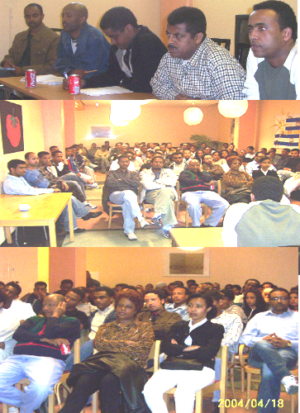
Members of AEASS in a meeting, April 18 2004
Objectives of AEASS

Association of Eritrean Asylum Seekers was established to achieve a number of objectives. These objectives can be grouped in three main categories namely advocacy, empowerment, and social mediation activities.

- Advocacy activities:

Advocating for human rights in Eritrea was one of the corner-stones of establishing AEASS. The purpose of these activities was to correct perceptions and impressions on both the situation in Eritrea and on Eritrean asylum seekers. This included, among others, the following:

● spreading awareness about the deteriorating political and human rights situation in Eritrea;
● changing the incorrect image taken on Eritrean asylum seekers within the Swedish asylum system;
● becoming vocal for our oppressed people in Eritrea;
● challenging, protesting and criticizing the unjust and illegitimate practices of the regime and its agents against the nation;
● collectively defend our right to asylum as stated in the Geneva Convention for refugees;
● creating social, cultural, recreational and educational activities/programs to enable asylum seekers live a normal life during their waiting periods;
● raising awareness among asylum seekers on issues related to asylum, rules, regulation, and norms of the society (civic education)

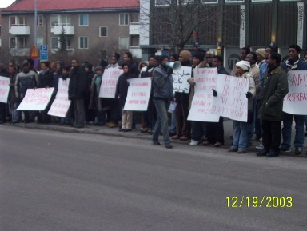
Members Of AEASS demonstrating against human rights abuses in-front of the Embassy of Eritrea in Stockholm, December 12 2003

To achieve these objectives the association, right after its birth, held a number of meetings with concerned government authorities including The Swedish Migration Board, Ministry of Foreign Affairs (Africa Department), Aliens Appeals Board and with some Parliament Members to raise awareness, draw attention and correct perceptions about the situation in Eritrea, Eritrean asylum seekers and about the high risk involved in deporting rejected Eritrean asylum
seekers to Eritrea. In this respect, to gain professionalism and effectiveness in its advocacy activities, the association prepared a written material titled ‘document prepared by Association of Eritrea Asylum Seekers in Sweden’ about itself, its objectives and the situation in Eritrea in addition to building an internet based home page (www.sedet_husum.itgo.com/www.eriasyl.com) to give an international dimension to its advocacy. Parallel to this, AEASS also organized a number of seminars on its own and in cooperation with concerned humanitarian organizations in defense of human and asylum rights. For instance in June 3 2005 AEASS, in coordination with Amnesty International, UNCHR, Red Cross, Caritas, and the Swedish Refugee Advice Center, held a very important seminar on human rights situation in Eritrea with focus on Eritrean asylum seekers in Sweden. The seminar was attended by all concerned authorities and addressed by Dr. Martin Hill from Amnesty International – UK, an expert on Eritrea, and it is believed that that seminar had played an important role in bringing about the positive change in asylum practices (asyl-praxis) for Eritreans that took effect in July 2005.

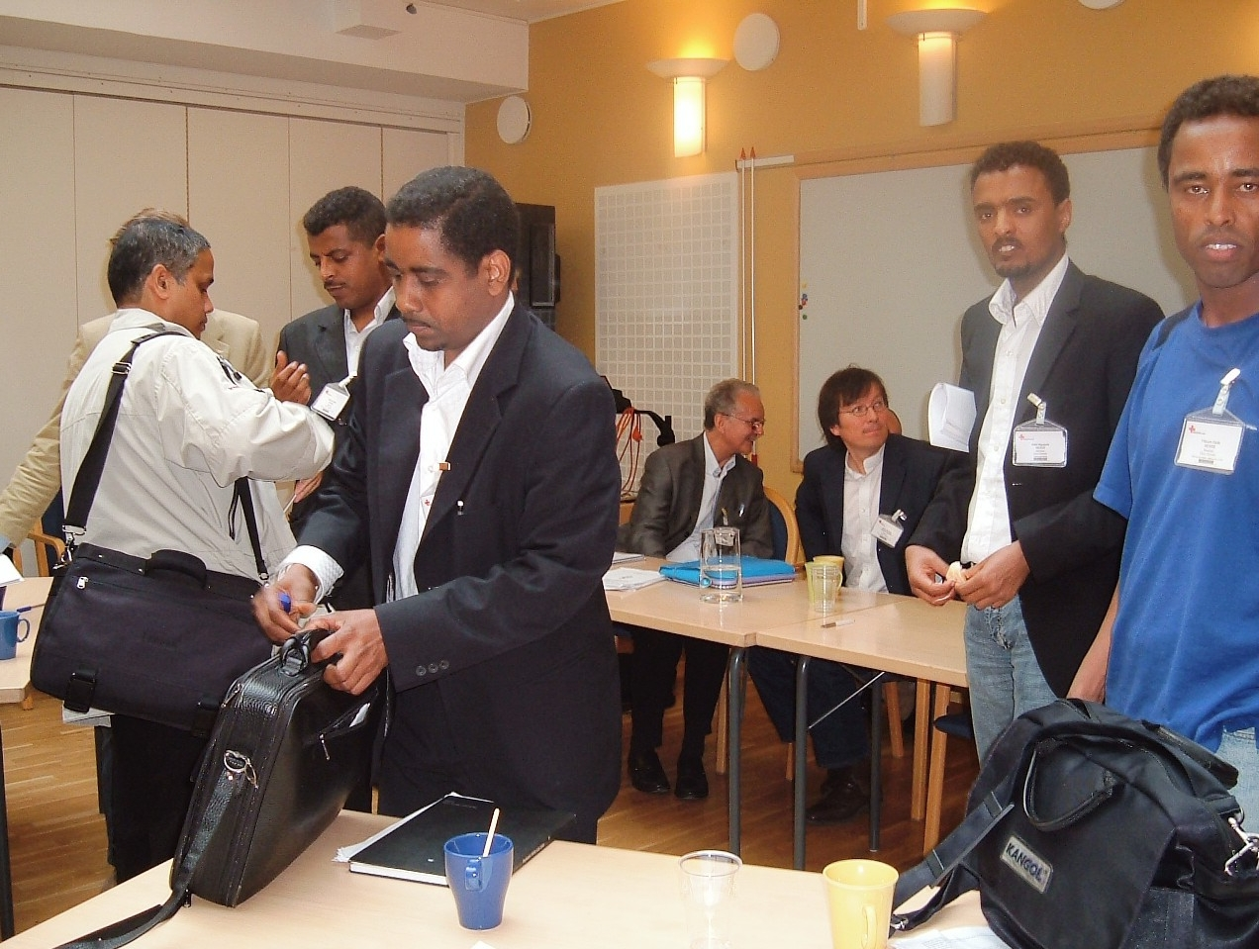
Seminar on Human Rights situation in Eritrea held June 3 2005, Stockholm.

Demonstrations, protest letters, petitions, manifestations, appeals, hunger strikes, TV-interviews and press releases were also other means AEASS had employed to spread awareness, build opinion and draw attention to its cause and to the deteriorating political and human rights situation in Eritrea. In cases of detention and threats of forcible deportation of a member these means also were used to show solidarity and avert deportation of the member in question – In two separate occasions, members of AEASS after demonstrating and making extensive contacts and appeals to the concerned authorities and human rights organizations succeeded in saving two members from imminent deportation. This event, which was a great success in saving human life from certain torture, was a sign of true passion and social cohesion AEASS created among Eritrean asylum seekers.

In conducting its advocacy activities, in addition to first hand information concerning the situation in Eritrea, AEASS also used periodical reports issued by reliable international organizations such as Amnesty International, Human Rights Watch, UNHCR and others which described the human rights in Eritrea as poor and called for careful investigation of asylum applications presented by Eritreans and to provide them complementary forms of protection even if their asylum applications failed.

2. Empowerment activities:

a. Social activities

Preserving and maintaining social life of asylum seekers’ was an objective AEASS worked hard to achieve. From the out-set, the Association paid special attention to enable asylum seekers live a relatively normal and meaningful life while waiting for a decision on their asylum applications and most importantly when a negative decision is made which makes life tougher. Given the fact that, in the past four to five years, waiting period for a decision was very long, asylum seekers were subject to prolonged periods of time filled with

uncertainty, anxiety, emptiness, and hopelessness. Severity of the situation increased when a negative(s) decision was made on the asylum application. This resulted in throwing asylum seekers out-side the formal reception system and consequently they lost the right to allowances, health care, education and the right to work. They were forced to become ‘the illegals’ as they are referred to.

In light of the above circumstances and given the fact that majority of Eritrean asylum seekers were in their early twenties and a considerable number of them had already their asylum applications turned down, it was timely and demanding to create some social/cultural and recreational activities to enable them make some sense of their life and to keep them away from bad habits such as alcohol, drugs, gambling and other harmful activities which they might resort to due to prolonged periods of waiting, loneliness or as a consequence of hopelessness and depression.

The benefits yielded by these activities were vast and remarkable. They played an important role and made a tangible difference in the lives of many asylum seekers especially among those who were forgotten and forced to live out-side the society for so long without any right and status. Hopelessness and powerlessness were turned into hope, belongingness and inclusion.

To fulfill this noble human message and to enable as many asylum seekers as possible to benefit from it, AEASS in cooperation with The Study Promotion Association (Studiefrämjandet) in Sundbyberg, organized a number of activities and programs aimed at creating educational and re-creational opportunities for asylum seekers to complement and in other cases as an alternative to the existing educational program (language courses) within the formal reception system which, seen from the asylum seekers’ perspective, was
short-termed program mainly treating participants as future returnees and not as potential members of the society. The language courses offered, especially to asylum seekers living within Stockholm, in its contents and duration was, to a greater extent, a waste of resources. According to many including myself, the program seemed as if it was mainly intended to make asylum seekers as busy as possible with little consideration to its efficiency and effectiveness which in its turn was a dis-motivating factor for participants already obsessed with the unknown outcome of their asylum applications.

The educational/vocational and recreational activities offered in cooperation with the Study Promotion Association benefited a large number of Eritrean asylum seekers in particular those whose asylum applications were turned down ‘illegals’ and those who had to wait for months to join a language program offered by the Swedish Migration Board. To them these programs created a precious opportunity allowing them to stay in touch with ordinary life. Through these programs AEASS benefited both the individual asylum seeker and the society at large.

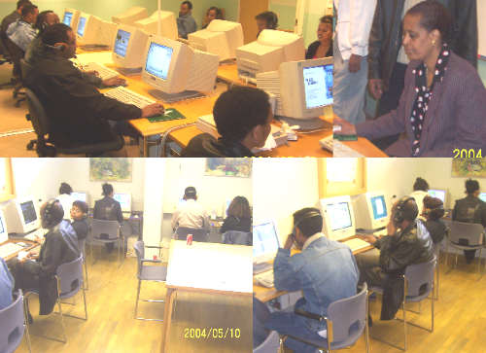
Computer classes at The Study Promotion Association, May 2005
The following are some examples of the activities/programs AEASS offered in coordination with The Study Promotion Association in Sundbyberg:

1. Swedish and English language courses
2. Mathematics
3. Computer courses
4. Sewing
- Dance lessons
- Sports (football and basket ball)
- Picnics/camping/workshops
- Drama/Theater
- Cultural evenings
- Training places ‘Praktikplats’

In June 2004 AEASS, together with the Study Promotion Association in Sundbyberg, and other partners, came up with an ambitious project titled ‘Man to

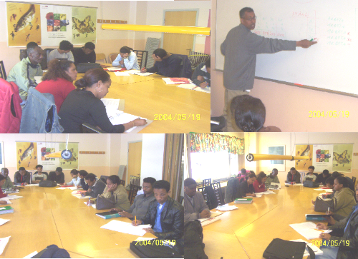
Language classes at The Study Promotion Association, May 2004
Man’ aiming at undertaking the above mentioned programs and others in a larger scale and more effectively. The project, which was estimated to cost a round 22 million Kronor and last for two years, however, was not approved by neither the European Social Fund not by the European Refugee fund to which it was submitted for funding.

In relation to this, in June 21 2005 AEASS in cooperation with The Study Promotion Association in Sundbyberg and National Thematic Network organized an important seminar titled ‘Empowerment of asylum seekers’ in which AEASS, as a self-organized association, presented its experiences in advocacy and in empowering asylum seekers. The purpose of the seminar, which was attended by different representatives from the government and central authorities and non-governmental organizations, was to draw attention to and to encourage similar self-organized asylum seekers’ associations and to provide them with necessary resources and if possible to enable them to take part in the provision of some activities of the formal reception system.

b. Contribution in solving social and financial difficulties:

AEASS gave a special attention to those members and in some cases non- members who had financial difficulties in particular the ‘’ illegals’’ who didn’t get any financial support from the Swedish Migrations Board. This type of members, who didn’t have anyone to care for them, found in the association a source of hope
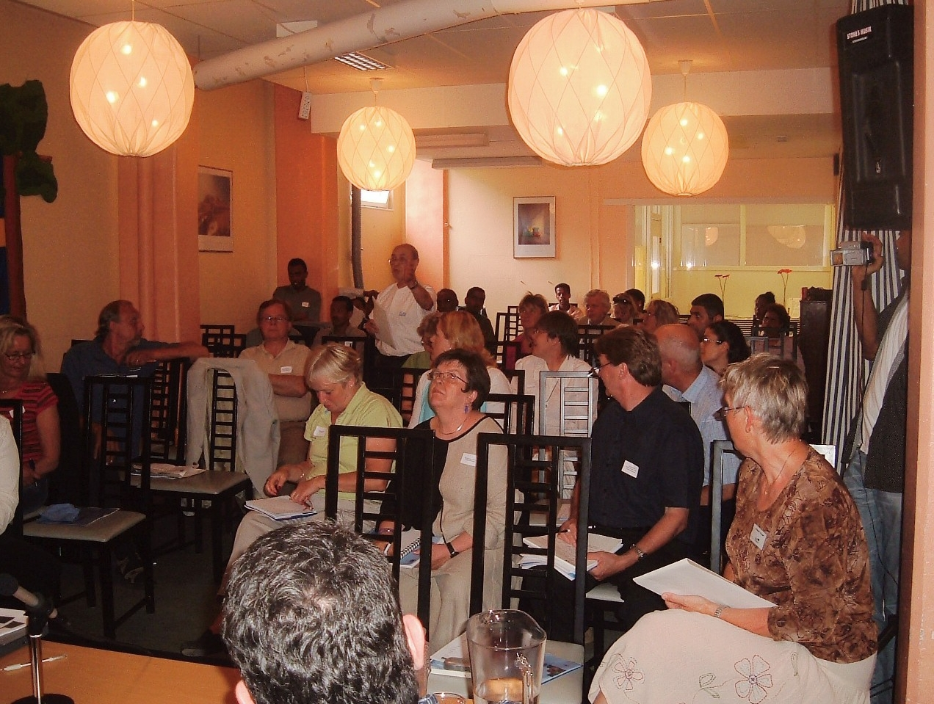
Seminar on Empowerment of Asylum Seekers held in SundbybergJune 3 2005, Sundbyberg

comfort and support. With membership subscriptions and other incomes generated from arranging cultural evenings, AEASS, within its means, financially supported those in desperate need with food, transport (SL- kort), and apartment rents and in other social crises such as death, lose of money and property. With the support of other concerned individuals, charity and humanitarian organizations, AEASS also assisted needy members with winter jackets, temporary employment opportunities and health-care for those who badly needed it but could not get it due to their ‘illegal’ status. AEASS also gave considerable attention to help asylum seekers with their asylum applications with the purpose of restoring their self-confidence and strengthening their faith in asylum and international laws. Before the establishment of AEASS it was found that majority of Eritrean asylum seekers had their asylum applications turned-down mainly because of their lack to correct asylum information, advice and in some cases due to misinformation from individuals who either didn’t know the facts on the ground or individuals who had some affiliations and interests with the regime in Eritrea. For this purpose a special unit within the Management Committee was formed to give advices and consultations to asylum seekers in issues related to asylum in addition to counseling services when a negative decision, loss of right to work and threats of deportation strike one of the members. Here it is worth -mentioning that these services were provided to any asylum seeker irrespective of his/her nationality who asked for it and there were also times that the Management Committee had been contacted by individuals, lawyers and organizations from Sweden and abroad seeking information, consultation and advice on asylum related issues and on the situation in Eritrea.
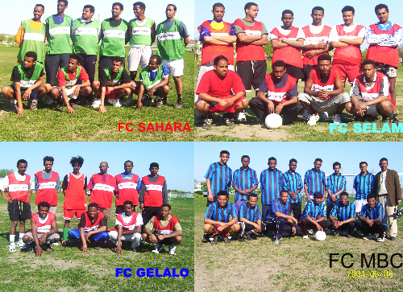
Recreational activities – Football teams in a competitions

The association assisted members with information, translations, interpretations, advices, and with making follow-ups to their asylum applications with lawyers, The Swedish Migration Board and the Aliens Appeal Board in particular when waiting prolonged and anxiety built-up. Most importantly, the association assisted and advised asylum seekers to become themselves when presenting their asylum applications. In the past, due to high rates of negative decisions among Eritreans, many Eritrean asylum seekers lost faith in asylum and confidence in themselves and thought getting a positive decision was unthinkable. This pessimistic attitude made a large number of them, in desperation, forgo their worthy backgrounds and mix up in what they present as grounds for their need of protection and of course this only added water to the clay. However, through orientations and awareness raising this attitude changed and eventually had positive results on the asylum applications of many. These moral and informational assistances helped many Eritrean asylum seekers to broaden their knowledge about asylum issues and to avoid unnecessary behaviors/acts which could have negative effects on their asylum applications.

c. Civic education:

Given the fact that majority of Eritrean asylum seekers are youngsters with little knowledge, if any, about asylum and it’s regulations, AEASS paid special attention to raise their awareness on issues such as: the Geneva Convention, the Migration Board, the Aliens Appeals Board, individual investigation of cases, appealing, interpreters, the Dublin Convention, Amnesty International, the Swedish Red Cross, UNHCR, sur- place protection and obligations to be fulfilled such as ID-documentations, presenting sound grounds for asylum, patience and respecting other asylum regulations. To fulfill this goal AEASS held periodical meetings for its members on weekly basis which by the passage of time changed into monthly meetings. These awareness raising meetings provided asylum seekers with valuable information which resulted in their empowerment. Through these meetings, AEASS also played a positive role in creating a sense of moral commitment among asylum seekers and this contributed positively in keeping them close to the developments in Eritrea and to speak on behalf of its voiceless and oppressed people. Furthermore, AEASS also gave especial attention to motivate and encourage members to learn the Swedish language and to continue their education/studies to increase future opportunities of employment and sound integration.
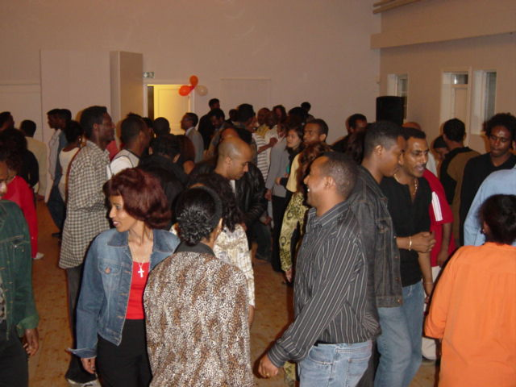
One of the cultural events arranged by AEASS August 2005 (Husbygård)

These meetings, in addition to their empowerment roles, they also constituted an important occasion for member asylum seekers to get the latest news on the asylum process, discuss their socio-economic problems, create social cohesion and to develop a spirit of oneness among themselves. To many, these meetings also provided a very important opportunity to come-out of their worries, depression, obsession and loneliness: They helped members to create and enjoy social relations.

3. Social mediation and conflict resolution:

Another field where AEASS actively worked was promoting understanding, tolerance, and civility among members of the association and with the society at large. The purpose of this was to enhance and develop a culture of tolerance among members in order to prevent conflicts and when they rose the association exerted maximum effort to solve them peacefully and friendly. In this regard, AEASS also played the role of confidence and trust building between and among the different Eritrean political and civil society organizations in Sweden. As a result of this, for instance, all Eritrean ‘democratic’ organizations, political and civil despite their differences, began to coordinate efforts in protesting, petitioning and demonstrating against human rights violations in Eritrea in addition to collectively organizing and celebrating national occasions (Independence Day, Martyrs Day). In this conjunction, the association also played an important role in raising awareness of asylum seekers on laws, rights, obligations, culture and norms of the society. The purpose of this was to prevent and resolve conflicts/disputes at individual and/or community levels which can arise due to misunderstandings, shortage of information and unintended behaviors.

It is here worth-mentioning that AEASS, in-order to raise public awareness on Eritrean asylum seekers has, in cooperation with the Study Promotion Association (Studeiframjandet), composed a drama/play reflecting the situation in Eritrea, describing the long adventureous trip made by asylum seekers to Europe and the challenges they face in their respective asylum countries. The play was written by members of the Association and performed by refugees/asylum seekers. The play so far has been performed in some schools and public institutions in Stockholm and it has won admiration and appreciation of many.

Achievements

In its two years (Nov.2003-Dec.2005) of devoted work, AEASS has recorded remarkable successes and achievements. While the attribute, in the first place, goes back to the Association and its members the role played by some sympathetic individuals and humanitarian organizations in bringing about these successes and achievements was essential too. To mention, Gunilla Moshi, a Swedish National from the Swedish Church, was our key and bridge to the society. Through her the Association made contacts with government authorities, humanitarian organizations and concerned individuals. She was our key to understanding codes and norms of the society. Amnesty International, UNHCR, and the Swedish Refugee Advice Center (Rådgivningbyrån) also showed full support and understanding to the cause of the Association and its activities. These achievements also wouldn’t have been easy to attain in the absence of the Study Promotion Association (Sundbyberg) limitless hospitality and generosity.

The following are some of the major successes and achievements made by the Association in its two years of advocacy and self-organization:

Among its main achievements was the positive change that occurred in perceptions on Eritrean asylum seekers and the situation in Eritrea. Continued awareness raising and information sharing with the concerned government authorities and humanitarian organizations resulted in bringing about a positive policy change (asyl-praxis) on Eritrean asylum seekers and accordingly a large number of Eritreans, as of July 2005, were granted protection and allowed to stay in Sweden. This radical development has enabled and encouraged those whose asylum applications were turned-down to come out of their hiding life and submit new applications which in most cases resulted in positive decisions as well.
During its first two years of advocacy, AEASS has acquired valuable experiences in issues related to asylum, self-organization and empowerment of asylum seekers. These properties placed the association in a position to become a source of information and advice for many asylum seekers and other individuals and organizations concerned with Eritrea and asylum matters. As a civil society organization devoted to human rights advocacy, AEASS also won the trust and support of several local and international NGOs and humanitarian organizations with whom it had built good understanding and working relations. With its uniqueness and effectiveness, AEASS also became an inspiration for asylum seekers in Sweden and abroad: Eritrean asylum seekers in different EU –states and other asylum seekers from different nationalities such as Libya, Iraq, Ethiopia and Somalia have on several occasions contacted AEASS requesting information and support to form similar associations.

AEASS also played a very important role in empowering asylum seekers through raising their awareness and understanding about several issues related to human rights, asylum’s regulations, integration and life in Sweden. A number of Eritrean asylum seekers today admit that AEASS has broadened their understanding and knowledge about many issues which they didn’t know and didn’t pay attention to.

Among the most important achievements of AEASS was its role in creating a positive social cohesion among member asylum seekers. It strengthened their sense of responsibility and interaction with the political and human rights developments in Eritrea and with the social and financial difficulties of fellow asylum seekers in Sweden and elsewhere.

AEASS within its means had also contributed effectively in solving some financial and social problems of member asylum seekers. This support besides being material, it also included some temporary job opportunities the association arranged on different occasions. In line with meeting social needs of asylum seekers, AEASS also created effective and meaningful educational and re-creational opportunities which played a very important role in maintaining and keeping members’ mental, psychological and physical well-being and in having well informed asylum seekers aware of their rights and obligations during the asylum period and afterwards.

Another important achievement of AEASS was the positive role it played in raising awareness about human rights abuses in Eritrea within the Eritrean community in Sweden. Due to this many broke their silence and joined the on going camp for democracy and human rights in Eritrea.

To see how these achievements were important in the lives of asylum seekers/’illegals’, I will refer to one typical case of a female Eritrea asylum seeker who got an initial negative decision and as a result was denied access to language classes (one of the organized activities offered by the Migration Board) and after a second negative decision she lost the right to social welfare and the right to work. In this case we will see how this woman was able to productively utilize her abundant time and what the role of AEASS was in changing her emptiness, powerlessness and hopelessness into hope, strength and inclusion.

She arrived in Sweden in June 2002. Four months after applying for asylum she began language lessons in Kallhäll (Stockholm). About one month later the Migration Board issued a negative decision on her asylum application. As a result of this negative decision she lost the right to attend language classes. Within three weeks she appealed the negative decision to the Aliens Appeal. About two months later the Aliens Appeal Board also rejected her asylum application. After these two negative decisions she lost the right to daily allowances and the right to work after refusing to cooperate with the concerned authorities to execute her return to Eritrea . As a result of this exclusion this female rejected asylum seeker was left on her own to adapt and re-adapt herself to the realities of being ‘illegal’ asylum seeker for almost three years until finally she was allowed to stay for reasons of protection needs under the ‘temporary law’ which was in force between 15 November 2005 and 31 March 2006 allowing rejected asylum seekers to submit a new application to assess their needs for protection and the right to stay

Due to the fact that this female asylum seeker was one of the founding members of the association and realizing that her return to Eritrea was surrounded with high risk due to her background which we were aware of, AEASS gave priority and special attention to her situation.

The initial step AEASS took to avert/suspend her deportation was submitting a new appeal application to the Aliens Appeal Board through the Swedish Refugee Advice Centre (Rådgivningsbyrån). This immediate action helped this female asylum seeker, despite all her worries, to feel some sense of security and that there were people who cared and stood beside her in her hardships.

Another measure which AEASS took to ease burdens of being out-side the system was allowing her to run a small café at the premises of the Study Promotion Association to make and sell tea and light food (sandwiches) to AEASS’s members who came to participate in language and vocational programs or visit AEASS’s office seeking assistance with their asylum cases. This opportunity,
although it was very nominal, however, it gave her strength, hope, sense of self-value, and satisfaction.

In addition to these two factors which made life relatively look brighter despite all difficulties, the language classes, computer lessons, and sewing lessons offered in
coordination with the Study Promotion Association also gave her an opportunity to invest her spare time in something meaningful and fruitful along side her ‘nominal job’

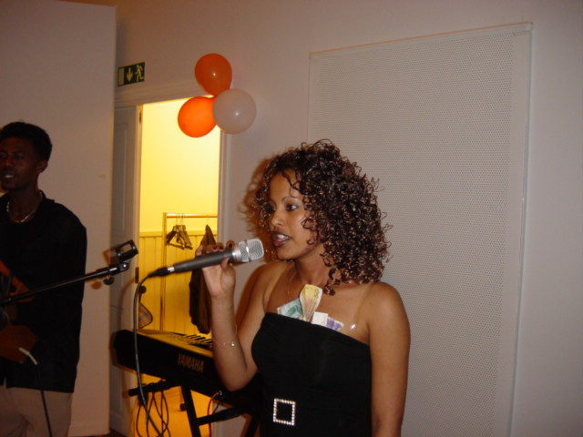
Two of AEASS artisters, Helen and Berekhet, in a performance

Challenges

Building an association in exile from the scratch with virtually no resources and past experiences was one of the main challenges AEASS faced in its procession. During the first few months following its establishment, AEASS received some assistance from the ‘Eritrean Popular Movement for Democracy in Sweden’. This assistance was in the form of arranging meeting halls for general members’ meetings held every week in addition to providing office equipments and stationeries. During that period, the Management Committee members, due to resource limitations, conducted their administrative, public relations and mobilization plans in cafes, apartments of members and sometimes in the open. This situation however, was overcome when the Study Promotion Association (Studiefrämjandet/Sundbyberg), provided AEASS with almost everything it lacked and needed. This included an equipped office, stationeries and meeting halls for holding general members’ meetings and a café where members could meet and relax. Generosity of the Study Promotion Association in Sundbyberg constituted a genuine source of empowerment for the association and it had played a central role in every achievement AEASS had made.

To have different members with different backgrounds, educations, age, culture and political affiliations add to this the fact that most of them have never engaged themselves and knew very little about civil society organizations, was a difficult task which demanded untiring efforts, strategies and plans to create an environment accommodating all differences, tendencies and aspirations.

Another challenge which faced and consumed much of AEASS’s time was the existence of a large number of members who had their asylum applications turned-down and forced to live out side the formal reception system. This type of members needed urgent assistance and they placed high expectations on the Association to meet that. However, due to limited resources, many of these desperate members, unfortunately, couldn’t be assisted. What also negatively affected the association’s ability to assist its needy members was the fact that members monthly subscriptions diminished because a large number of them lost the right to state financial support after having their asylum applications turned-down. The overall effect of this was reflected on the number of members participating in the educational and vocational activities which remarkably began to go down due to financial constraints (transportation) and psychological unrest. The increase in the number of negative decisions made many suffer from harsh psychological complications which, unfortunately, in one case, resulted in one of them committing suicide. These financial limitations also constrained AEASS’s ability to physically reach the big number of Eritrean asylum seekers stationed in different reception camps who were in greater need of organization, support and orientation.

What also made the mission of AEASS challenging was the unfriendly and aggressive behavior of supporters of the government in Eritrea against the association and its members. From the early days of AEASS’s birth, the Embassy (Eritrean) and its followers did everything in their ability to threaten and deter members to disassociate themselves from the association. Accordingly, a number of asylum seekers and some members who either had family ties with government supporters or those who feared safety of their families back in Eritrea preferred, unfortunately, to keep themselves distant and watch.

AEASS transforms into EDHR

After our seminar of June 3 2005 on the human rights situation in Eritrea, asylum practices (asyl-praxis) on Eritrean asylum seekers witnessed a positive improvement and a new practice was introduced. As a result of that a large number of Eritrean asylum seekers even those whose files were closed long ago, have been granted protection and allowed to stay in Sweden. With the realization of this important change, AEASS achieved one of its main objectives: advocating for asylum rights and saving Eritrean asylum seekers from forced deportations. Therefore in its second annual conference held in December 03. 2005, AEASS transformed into a broader civil society organization called ‘Eritreans for Democracy and Human Rights, EDHR. The purpose from this transformation was to widen its membership to include every Eritrean and none Eritrean interested in defending human rights, promoting democracy in Eritrea and empowering Eritrean asylum seekers in Sweden and elsewhere.

After this transformation, realizing the importance of integration and the obstacles experienced by new-comers due to lack of information, orientation and civic education, EDHR, in cooperation with Studiefrämjandet, has began offering a civic education program ‘study circle’ on Democracy, Human Rights and Civil Society to anyone interested in widening his/her knowledge about these essential values and principles. With this civic education, EDHR aims at raising awareness among immigrant, refugees and asylum seekers from the Horn of Africa on the above mentioned issues. The overall aim of this program is to develop principles of civic culture, tolerance and better understanding among and within these groups and to empower them with these principles with the view of enhancing their integration and participation in the society. As was the case with the previous empowerment activities for asylum seekers, this civic education program affirms the importance Eritreans for Democracy and Human Rights-EDHR- attaches to surrounding refugees, immigrants as well as asylum seekers, with the necessary information and basic knowledge needed to bring about a positive change in their thinking, attitudes and ambitions.

Another project which EDHR is due to launch is a ‘Social mediation in refugee communities’ in coordination with the International Organization for Migration (IOM), and other partners. This project, as the name implies, aims at promoting understanding, tolerance and awareness between the refugee communities and the society in order to prevent and resolve conflicts arising from misunderstandings and cultural differences. The project is scheduled to start November this year and is planed to start with the training of ten individuals on social mediation who will in the future work as trainers and social mediators.

To cope with its organizational transformation and to preserve the good image created on Eritrean asylum seekers, EDHR has now among its top priorities conducting a number of meetings with the concerned government authorities and humanitarian organizations in order to, on the one hand, sustain the positive image created on Eritrean asylum seekers, on the other hand, to keep the authorities and organizations updated on the situation in Eritrea which has not witnessed any improvement. To the contrary conditions kept deteriorating forcing more and more people to leave the country fleeing persecution and searching freedom.

Conclusion and remarks

One of the most harsh and cruel moments in ones life is when he/she flees his/her home country and becomes a refugee seeking protection and asylum in another country. In today’s tight immigration regulations and complex asylum policies however, achieving this need, which is guaranteed by International Conventions, has become very difficult. As a result many eligible asylum seekers with well-founded fear of persecution, unfortunately, are being denied protection and forced to live under extremely harsh circumstances in their respective countries of asylum.

In the past two to three years, Eritrean asylum seekers in Sweden experienced such difficulties. A large number of Eritreans, have had their asylum applications turned-down and many others were on the waiting list for deportation. To change this reality, empower and save Eritrean asylum seekers from certain human rights violations upon deportation, Association of Eritrean asylum seekers in Sweden (AEASS) was established. The association which is a unique experience for self-organization, has in the last two years scored some impressive achievements. The association became a valuable source of information, orientation, advice and consultation for asylum seekers in issues related to asylum and its regulations. It also constituted a social space where asylum seekers, in particular the so called ‘illegals’, could make use of the educational, vocational, and recreational opportunities the association had created in cooperation with Studiefrämjandet. In times of desperation the association was also a source of financial assistance to those who lost the right to social welfare.

The role played by these activities in terms of empowering asylum seekers is not difficult to imagine. They contribute in having well informed, confident, and balanced asylum seekers aware of their rights and obligations and the benefits of these to the society during the asylum period and in future integration efforts of these new-comers are valuable.

From this unique and successful experience of Association of Eritrean asylum seekers one can conclude the following:

First, asylum seekers are vulnerable groups they shouldn’t be left on their own. They need support, guidance and orientation through an effective asylum reception system. Saying this however, asylum seekers themselves have also a responsibility to take the initiative and organize themselves to overcome whatever challenges they face in attaining their need for protection. In cases of lack of accurate and up-to-date information, asylum seekers need to organize themselves in order to raise awareness, lobby and draw attention to the human rights situation in their home-counties. Parallel to this, to avoid undesirable consequences of prolonged waiting periods, and to utilize their surplus time in the best possible and productive way, asylum seekers need to organize activities/programs positively affecting their mental, physical, psychological and social well-being which do have important bearings on their future integration if they are granted asylum and become part of the society.

Second, asylum seekers during the asylum process should be viewed as victims and not as charges or threats to the society. Generalizations and strict asylum policies can make genuine asylum seekers victims of torture and other inhumane practices if forcibly deported. The Geneva Convention of refugees is a noble document created by mankind emphasizing solidarity and humanity among nations.

Third, concerned government authorities, humanitarian organizations and concerned individuals should encourage, support and recognize such self-organized associations. They are precious resources which can positively contribute in empowering asylum seekers and in undertaking some of the organized programs/activities offered during the waiting period effectively and efficiently.

Fourth, asylum seekers come from different social, political, economic, religious and cultural backgrounds. To enable these different groups integrate into the society in the future, it is essential to lay grounds for that at early stages. Waiting period ‘asylum period’ is the starting point. If, during this stage, asylum seekers are enabled to optimally exploit their time, if they are given proper orientation, civic education, and effective language course(s) through out the waiting period, this can, in the final analysis, accelerate their future integration and proper inclusion in-to the society when their asylum applications become successful or when safe-return of rejected asylum seekers becomes impossible due to conditions in countries of origin.

Finally, while priority must always be given to the protection needs when assessing asylum applications, asylum seekers bring with them rich experiences, expertise and qualifications. These traits can be exploited in educating, enlightening and empowering their respective immigrant communities in particular those which are claimed to be ‘the least integrated’ communities - Language constraints and cultural differences among immigrant communities can slow and retard their integration into the society.

--------------------------------------------------
END
BIBLIOGRAPHY

References/Documents:

- Document prepared by Association of Eritrean Asylum Seekers in Sweden, Stockholm, Nov. 2003
- UNHCR position on return of rejected Eritrean asylum seekers, Geneva, January 2004

Internet:

- www.unhcr.org
- www.migrationsverket.se
- www.hrw.org

Interviews:

1. Telephone interview with member and former rejected Eritrean seeker, Stockholm, 2006.08.09.

http://www.afrol.com/articles/19044
www.unhcr.org
www.migrationsverket.se * For information about the situation in Eritrea visit: www.amnesty.org, www.state.gov
www.hrw.org/wr2k3/africa4.html
Document prepared by AEASS, Stockholm, Nov. 2003
UNHCR position on return of rejected Eritrea asylum seekers, Geneva, January 2004.
The Study Promotion Association is one of the largest associations for adult education in Sweden. It organizes study-circles, cultural events, seminars and projects aiming at giving people the opportunity to increase their participation in society and to provide tools for self-development and life-long learning. ( www.sfr.se/in_english.htm)
(1)Since 2002, there is a National Thematic Network (NTN) on Asylum within the EQUAL Initiative in Sweden, funded by the European Social Fund. The Network includes representatives from concerned authorities, the European Refugee Fund and the Development Partnerships and the projects within the Asylum Theme. The aim of the Asylum NTN is to act as a collective resource at national level to strengthen efforts to disseminate positive experiences and influence system and policies. The National Thematic Network analyses, monitors, and evaluates project experiences and results from EQUAL and European Refugee Fund financed activities. The group initiates and contributes with relevant research and development activities (www.temaasyl.se)
Interview with former rejected Eritrean asylum seeker, Stockholm, 2006.08.09
www.migrationsverket.se

