

Foto: Martin Israelsson

September 2007 The European Refugee fund decided to grant a research project to find out if International Health Advisors can make a difference.

Health inequalities
Several studies in Sweden have shown, that the health of the foreign-born population, and even of those with foreign background (Swedish-born but both parents of foreign origin), is worse that that of the population with Swedish background. The migration process itself affects the health by high level of stress and by heavy personal and socio-economic losses. Upon arrival in the host country, immigrants may be excluded in many senses – the language is new, and it may be difficult to enter the labour or the housing market. Many of these factors explain the health inequalities, but vice versa, health is also an important resource for social and economic integration.

International Health Advisors
International Health Advisors was a project developed within the frame of the governmental Metropolitan City initiative and the European Community Initiative Equal. The project has dealt with two of the most central issues in the Swedish integration policy: to enable the enjoyment of the same rights and opportunities as the general population – in this case through providing newly arrived refugees and asylum seekers with information -- and to raise awareness and disseminate knowledge about the need for difference sensitivity -- in this case in health care practice.
The International Health Advisors’ work focuses on three themes: access to health care, disease prevention and health promotion. This happens through education in cooperation with introduction programs offered to all newly arrived refugees. The main contents are: information about the health care system and its utilization, self care for alignments and health promoting lifestyle. The information and advice are as far as possible given in the mother tongue of the migrants. Written information in Swedish is handed out and the Swedish language teachers are using this to train the participants to use the knowledge in their contacts with the health care.
The International Health Advisors also work in primary care. The advice sessions mainly concern child care. Group activities for people with diabetes or people in need of physical activity are run.
The evaluation studies performed along the development of the International Health Advisors’ work are unambiguous. Health care staffs experience a relief in pressure on the services, and that they now are meeting with more knowledgeable patients. Teachers in Swedish language classes also appreciate the effects. A lot of queries addressed to teachers before are now addressed to the International Health Advisors.
However, no controlled evaluation has been done so far on the health effects on the target group. There is no evidence of increased knowledge and better health among the migrants who have participated in the International Health Advisors’ interventions.

Impact of Health Advisors
The European Refugee fund granted the study 1.8 million kronor for the time period September 2007 -- September 2008. The application presented a study that requires a four years period till end of 2011. A second application will be addressed the European Refugee Fund III 2008-2013 for the second research period. The study will evaluate the effects of the International Health Advisors’ work for the target group. Its main aim is to determine whether or not there are public health and health economic effects. If effects can be found, the study can provide arguments for development of the International Health Advisors’ profession, by creating a nation-wide training program and by creating positions for International Health Advisors in the whole country.
The study will be run by a partnership consisting of Scania Region, Lund University, Malmö University and Uppsala University. A reference group of organisations following and supporting the process will be tied to the partnership, to secure good input and dissemination. Organisations in this group are among others the co-applicants Östsam, the County council of Blekinge and Blekinge Institute of Technology.
Susanne Sundell Lecerof will perform the study and representatives of the partners will act as an advisory board to secure the quality of the research.
The study is presented on the opposite side of this leaflet.
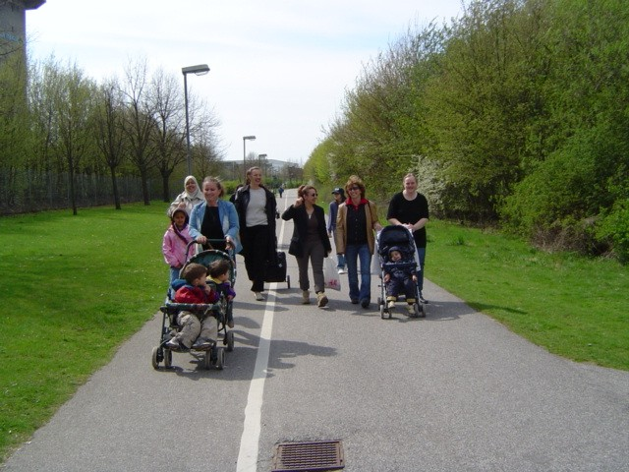

Overall aim and objectives
The overall aims of the evaluation study are as follows:
- To undertake a prospective longitudinal cohort study on the effects on public health and health care utilization of the International Health Advisors’ work among Iraqi asylum seekers and Iraqi newly arrived refugees in municipalities compared to not having access to International Health Advisors.
- To undertake a health economic evaluation (a cost-benefit analysis) of the effect on health-related quality of life of the International Health Advisors’ work among Iraqi asylum seekers and Iraqi newly arrived refugees in municipalities compared to not having access to International Health Advisors.
- To undertake a qualitative study on experiences of the health care services and the International Health Advisors among Iraqi asylum seekers and Iraqi newly arrived refugees in municipalities.
The specific objectives of the evaluation study concern nutrition, physical activity and BMI; mental health and self-rated health; health-related quality of life; health care utilization, unmet health needs and self-care among the participants and their children; and experiences of the health care services concerning information, accessibility, and treatment.

Material and data collection methods
The baseline study is to be conducted during spring 2008 and the follow-up study after 1½ years (fall 2009). The data collection will be done through a questionnaire containing internationally validated instruments.
The cohorts consist of approximately 750 individuals each, out of which approximately 500 (in total) are Iraqi asylum seekers and the rest Iraqi newly arrived refugees in the following municpalities: Malmö, Karlskrona, Ronneby (and perhaps other municipaities in Blekinge county), Linköping, Norrköping (and other municipalities in Östsam region) in the exposed cohort; and Södertälje, Göteborg, Örebro, Kalmar (and perhaps Uppsala and Karlshamn) in the unexposed cohort. The municipalities are comparable when it comes to size of population and number of Iraqi asylum seekers received and new residence permits for Iraqis.
For the qualitative study, a broad sample selection (sex, age, educational background etc) out of the questionnaire respondents who volunteer will be utilized. Focus group discussions on the preliminary themes (information, accessibility and treatment) will be held, complemented by individual in-depth interviews.

Analyses
The statistical analyses will be done in SPSS and compare the two cohorts over time when it comes to risks/incidence rates of poor diet, sedentary lifestyle, obesity, mental ill-health, low self-rated health and low health-related quality of life.
The proposed causal mechanism suggests that the International Health Advisors’ effect on the participants’ physical and mental health, and their health care utilization, is mediated by social capital.
Different possible confounders will be adjusted for in statistical models – for example socioeconomic factors (employment, education, income and housing), and factors related to the migration process (asylum status, family reunification and experience of discrimination).
The health economic study will use EQ-5D and EQ-5VAS with a time-trade-off question in order to assess the value of health-related quality of life for the target group. The two cohorts will be compared when it comes to QALY gains.
In the qualitative study, interviews will be tape-recorded and transcribed verbatim. The data will be coded and analysed according to a phenomenographical method, in order to achieve a broad description of the participants’ experiences, and a deeper understanding of their perspectives.

Implications for practice and dissemination
The over-arching purpose of this ERF research project is to determine whether or not there is evidence of effectiveness of the International Health Advisors’ work. The evaluation study will generate recommendations for method development of International Health Advisors. These recommendations will be disseminated through the reference group in which also Swedish National Institute of Public Health and The National Board of Health and Welfare will be represented.
The findings will also be disseminated through the European research collaboration COST, within the field of migration and health: “HEALTH AND SOCIAL CARE FOR MIGRANTS AND ETHNIC MINORITIES IN EUROPE”, funded by the Seventh Framework Program. (http://www.unige.ch/ses/socio/milenachimienti/Recherche/COSTproposal.pdf)

