Portuguese Presidency of the European Union, Autumn 2007
Health and migration - Good Practice Example

Empowering migrants – health promotion and accessibility
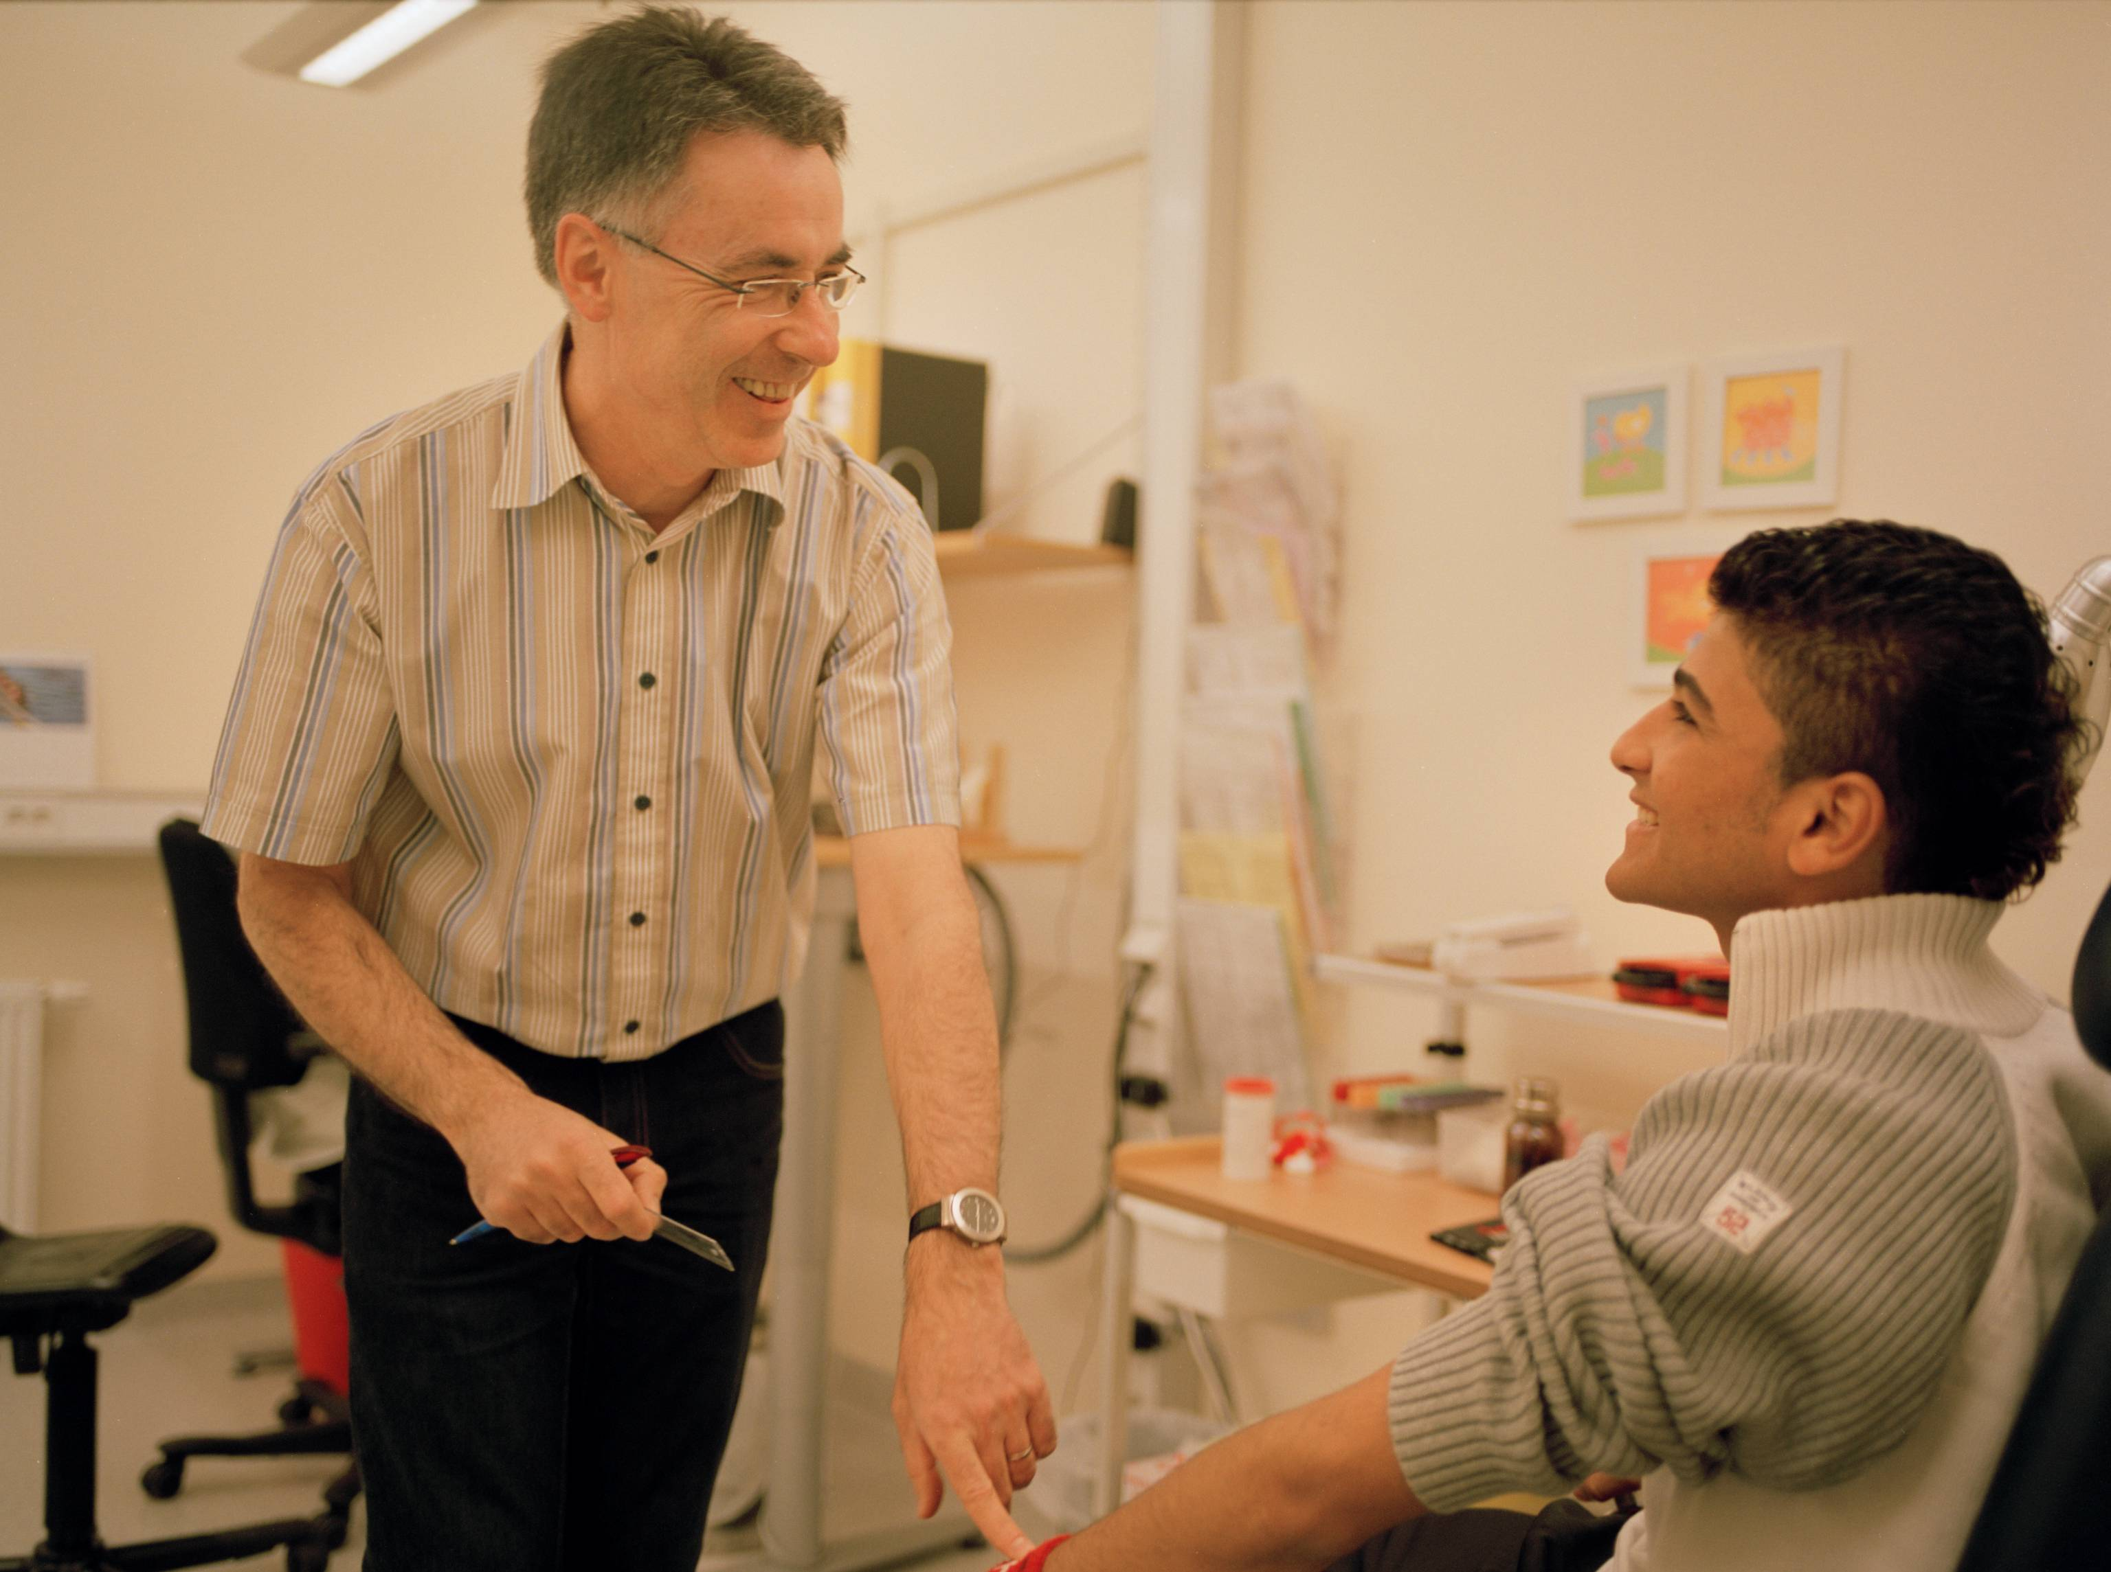

Introduction
Studies indicate that public health is poorer among immigrants than among the average Swedish citizens. The migration process itself affects the health by high level of stress. Several reasons are to be found in the fact that immigrants are excluded in many senses. Immigrants have also suffered heavy losses e.g. economy, family and social position.

City of Malmö – home of International Health Advisors
City of Malmö is situated on the very south west coast in Sweden. 26% of the inhabitants are born in foreign countries. Health problems do not just affect the person suffering from poor health but also the whole family and especially the children. Poor health hinders people from participating in education activities and training programs, excludes people from the labour market, causes high costs for the society and interferes with economic growth.

Goals and Objectives
Raising awareness of healthy lifestyle and knowledge about the health care system
One idea to combat health inequalities was to raise knowledge among immigrants about health, self care, health promoting lifestyle – physic activities, healthy foods, sleeping habits, drugs – and about the Swedish health care system and how to use it. This resulted in a project called International Health Advisors, IHA.

Combating inequalities in health and reduce costs
The IHA projects aimed at combating inequalities in public health and promote health among immigrants. An equally important objective was to reduce the costs for the society in form of high costs for medical care and treatments, for unemployment due to ill health and for social problems caused by a large group of citizens being excluded form normal living conditions.

Taking advantage of immigrants competences and reducing unemployment
The IHA project was also expected to make use of immigrants with experiences and training in medicine and care from their countries of origin but being unemployed. They were not able to work in their former occupations as doctors, nurses, dentists, physiotherapists etc since they did not meet with the requirements for these occupations in Sweden. By employing theses immigrants and training them for the specific duty as International Health Advisors, IHAs, they could become self-supportive, use their abilities and contribute to the development of the society. The IHAs’ multicultural and multilinguistic competences made them special and not interchangeable with others.

Model
IHAs are building bridges between immigrants and the major society. The framework of health advising activities is the introduction program inclusive the course Swedish for immigrants. This arena is used since it guarantees that the main part of immigrants will be addressed. Other very important arenas are primary health care centres and the child health care centres. By advising parents it is presumed that the effects will be sustainable.
Health advising activities in special classes, lead by people talking the mother tongue of the participants and having very much the same experiences from the time before migration and the migration process, is presumed to be effective, due to trust, since the advisors are being regarded reliable.
Health advising sessions are also offered to NGOs and performed in cooperation with NGOs, mainly organised on an ethnic basis.

Field or determinant
Health promotion, preventions to keep healthy, knowledge about the health care system and how to use it, about attitudes towards medical treatment contra life style factors for treating ailments, the medical staffs’ different duties and competences and differences between bacteria and virus, and their different treatments, are areas covered. Mental health problems are brought up as well as sexual health and sexually transmitted diseases. It’s regarded that knowledgeable persons can behave adequately within the system; make well grounded choices and take appropriate decisions.
Asylum seekers in Sweden are offered a health screening program consisting of a general examination and an interview about the individual’s health as well as the health of the family if appropriate. An IHA is available at the Health care centre for asylum seekers, Vårdcentralen Flyktinghälsan. The advisory sessions deepen the information given by the nurses and aims at convey trust and security.
Asylum seekers are offered Swedish language tuition. IHAs give lessons, integrated in the educational program.
People with a permanent residence permit are offered Swedish language tuition, information about the society at large, the labour market and possibilities to practice in a workplace in an integrated package, often called introduction program. In Malmö the IHAs give lessons integrated in this program to promote health and combat inequalities in health. In these programs it is strongly stressed that the Swedish language teachers shall elaborate the content in this health advising sessions to deepen the understanding and to support the immigrants acquiring skills to deal with the health care services in Swedish. This will lead to more adequate treatment when needing care and it will lower the costs for interpretation in the health care system.
At child health care centres IHAs can explain more thoroughly the information given by the Swedish speaking staff and establish trust and security. IHAs invite to group sessions where they talk about bringing up children, about healthy foods, children’s diseases, vaccination programs, about preventing health problems by e.g. not giving babies and children sweet drinks and biscuits.
IHAs work together with specialist care in order to produce material that can be used in classes for persons with certain diseases to teach them self treatment and how to lead a good life despite the health problem.
IHAs also produce information material in writing illustrated by pictures to support the advising sessions and to invite to new sessions.

Scope
IHAs in Malmö are organised as a unit within the primary health care. The work is performed within the legislation concerning the health sector. The content and the quality are guaranteed by the health authorities on the regional level overviewed by The National Board of Health and Welfare.

Provider
Health advising activities for immigrants are run by several municipalities and cities, very often in cooperation with Regional Boards of Health. By presenting the advisory activities within the introduction courses offered to almost every newly arrived immigrant – despite of legal status – a high number of the total group is reached.

Resources
The project was initially from 2001 funded by the National Metropolitan initiative, by the City of Malmö and the Regional Board of Health in Region Skåne. During the period 2002-2005 the Equal program within the European Social Fund has contributed to the funding and thereby have also asylum seekers become a target group.
Today is the health advising activity mainstream and funded equally by the City of Malmö and the Regional Board of Health in Region Skåne.

Management
IHAs are organised as a specialist unit within the primary health care and coordinated by a manager. The service can be ordered free of charge. The manager will prioritise the requests.
The health advising unit has during the establishing period been ruled by a special board. Today it is integrated in the normal democratic and organisational steering system for health service.
It has been very important to introduce and firmly establish trust and reliance between the permanent health care staff and the IHAs. It must be secured that IHAs are working in line with the public health regulation and legislation. The messages and advices must be unambiguous and correct.
Trust and reliance between teachers and IHAs is equally important. The teachers must also be well informed about the topics presented to be able to continue the health promoting work within their classes.
Equally important is that IHAs are confident in their roll and don’t appear as doctors or nurses, as their occupation was in their country of origin, since this could cause a lot of confusion.

Indicators
So fare there is no controlled studies made on the result on an individual basis on the target group. A lot of evaluation studies are performed along the development of the health advising institution. The results are very unambiguous.
Stakeholders as nurses and doctors say that the health advising activities have relived the pressure and that they now are meeting with more knowledgeable patients and that they can refer patients to the IHAs to get more and deeper understanding of the treatment or why treatment isn’t given.
Teachers likewise appreciate the effects by the IHAs work. A lot of questions, queries and anxiety addressed to teachers are now addressed to IHAs. Whether the immigrants being advised by IHAs have become healthier is not yet proved. But there are signs that they feel more secure and act more adequate.
Controlled studies and surveys to get information on the effects of IHAs’ work is planed and will be performed autumn 2007 and in a longitudinal research three years ahead.

Results
Nurses in primary care centres in areas with a high population of immigrants confirm that people are more competent today in their contact with the primary health care.
Teachers in Swedish language classes say that the knowledge gained by the advising sessions has made students feel more safe and secure.
Confidence in understanding and acting in the new society is important for the integration process.
Immigrants express great appreciation about the International Health Advisors.
IHAs themselves feel proud of their work and possibilities to promote equal health.

Conclusions
IHA can make a difference. If health is increasing among immigrants more people will be able to enter the labour market and become self supportive. This will effect the integration and the economy on an individual as well as on a society level.
Costs for health care can stop rising or even decline when health care is used in an adequate way.
Patients feel that they are listened to and they feel secure with the diagnoses and treatment given.
If individuals in the target group change their life style, to be more health promoting, the IHAs work would even affect the public health at large.

Future
Today a project is running to disseminate the models and the results, and to influence other municipalities and regions to establish IHAs.
IHAs can be used by pharmacies and in services to elderly people who do not know Swedish very well or who has, due to diseases related to aging, forgotten the Swedish language.
There is also ongoing work to establish a nationwide training program to become IHA and to legitimise the profession.
The first steps to inform the EU Commission, DG Employment, Social Affairs and DG Equal Opportunities Justice, Freedom and Security to realise the possible effects of IHAs were taken 2005 within the ASPIRE! project, a transnational partnership within the Equal program. These ideas are also to be disseminated to DG Health and Consumer Protection.

References
”The International Health Advisors offer the health care staff an opportunity to understand patients with different cultural background. At the same time they offer the patients an understanding of how Swedish health care system works.”
Ingemar Götestrand, Head of Primary health care, Region Skåne
We have noticed that the work performed by the International Health Advisors has resulted in asylum seekers requiring health care in a more adequate way. Now they know how to treat ailments themselves. That’s positive.
Gitty Hildingsson, nurse at the Health care centre for asylum seekers

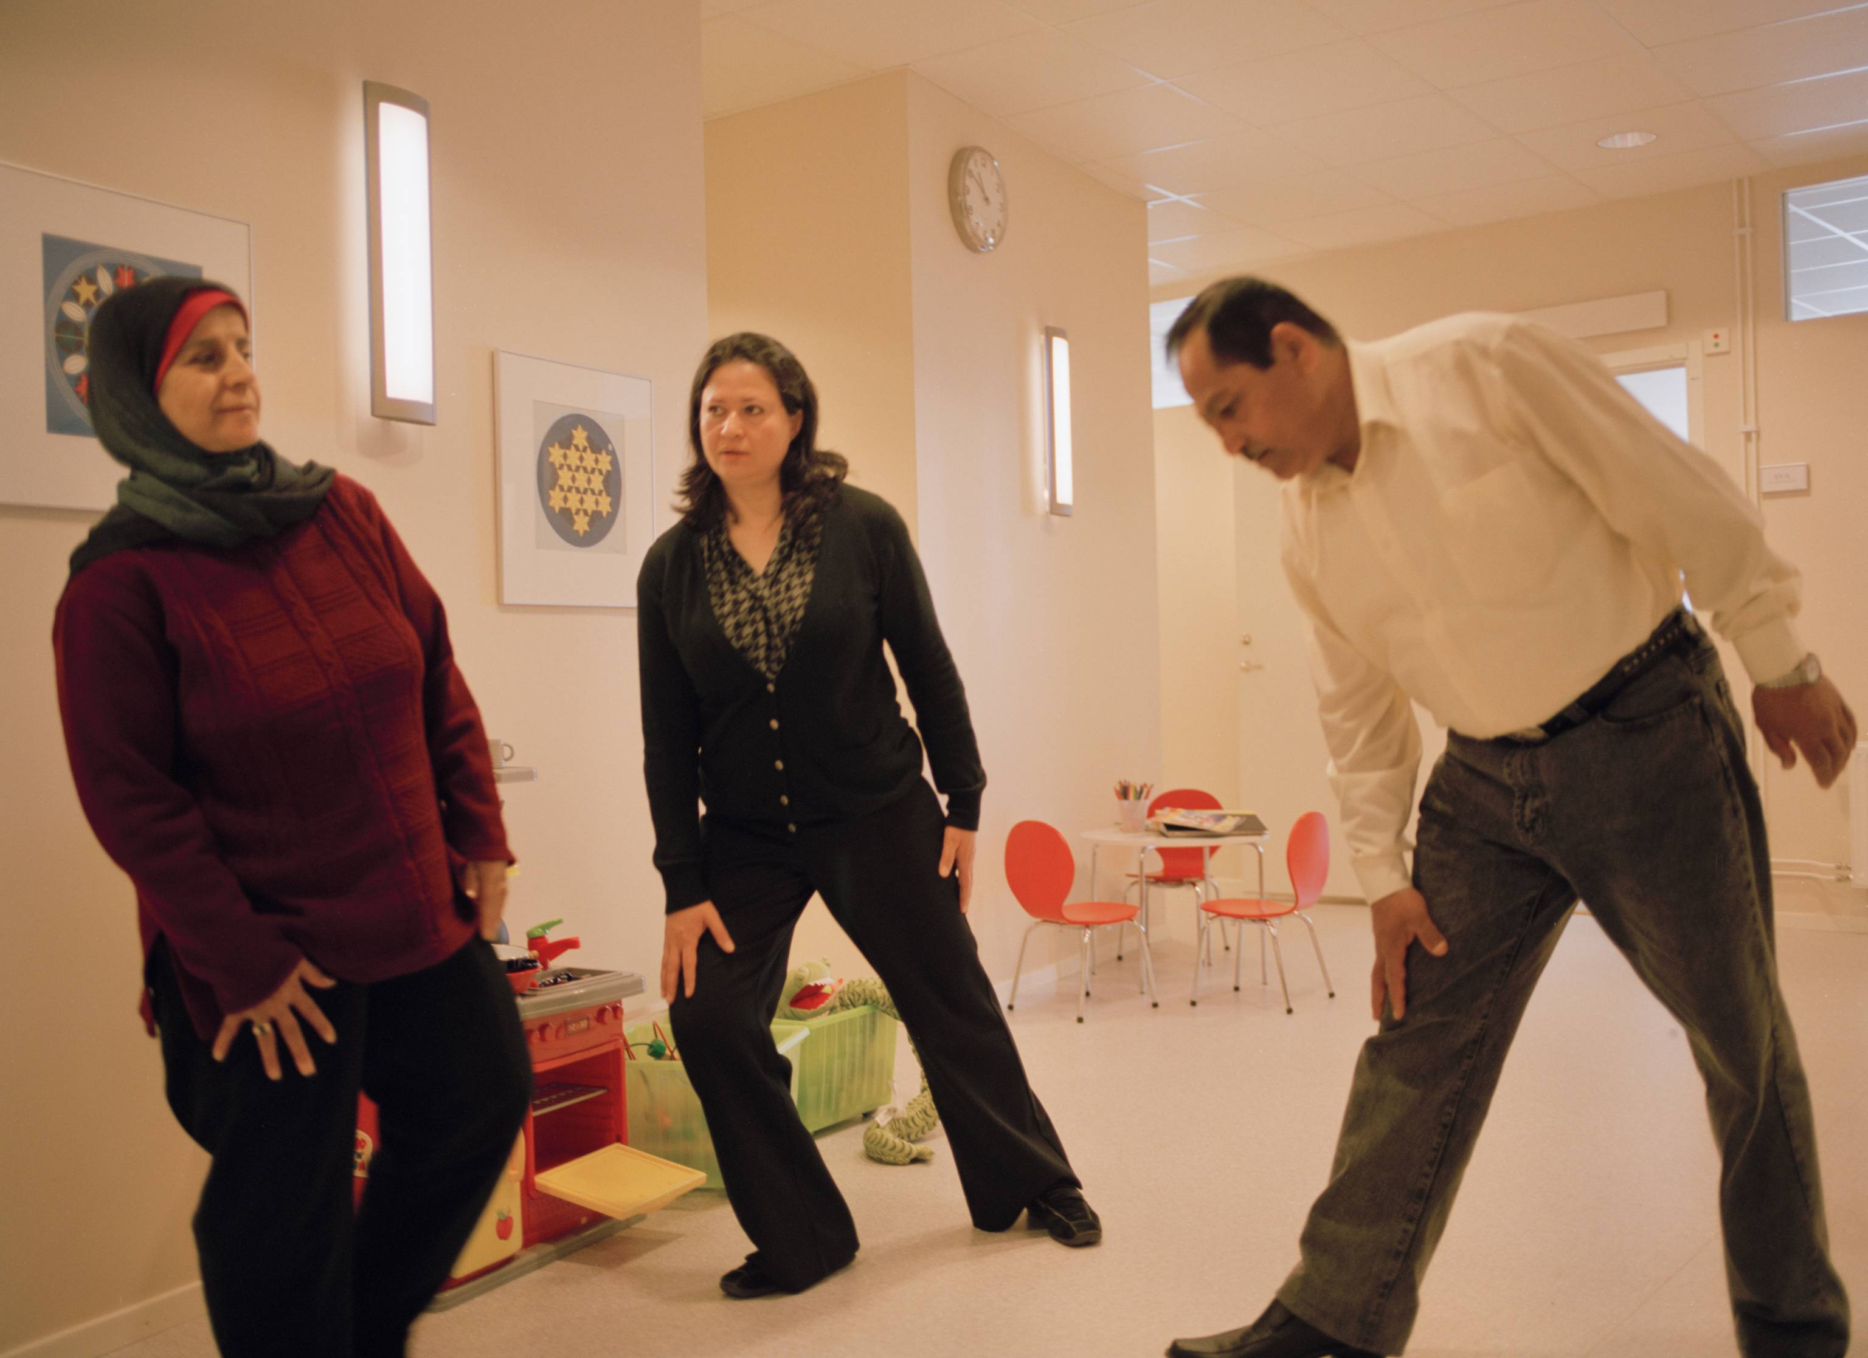 Foto: Martin Israelsson
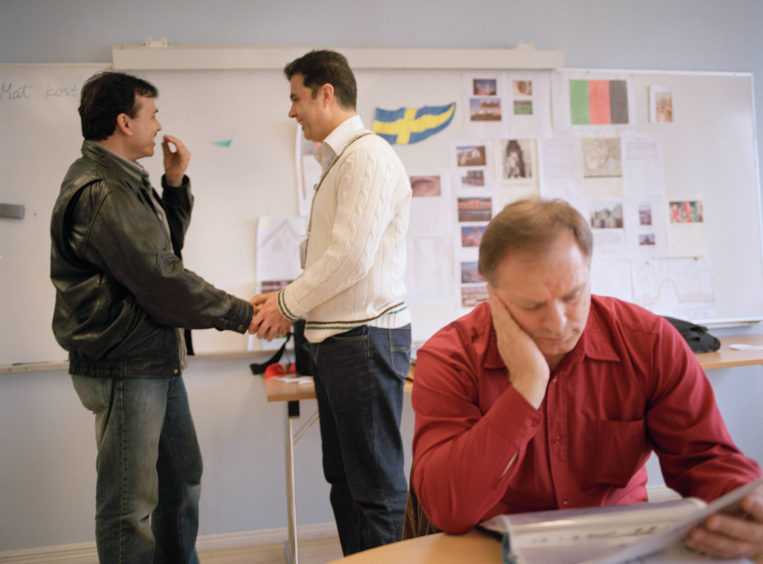 Foto: Martin Israelsson
“In my native country people not usually lead a life that will be health promoting. You go to the doctor when being sick, but you don’t expect the health care to help you to keep healthy. This is a new way of thinking.”
Huda Mahdi,
International Health Advisor

“Since we understand the background and culture of the immigrants and share their experiences of migration, people we advice rely on us.”
Nangyalai Ghairat International Health Advisor

Lessons learned
Weaknesses.
There is no nationwide training program to become International health advisors.
There is no acknowledge position for IHAs today.
The effects by the IHAs work has not yet been proved by controlled research studies.

Strengths
The IHAs are highly appreciated among health care staff.
Immigrants who have met with IHAs appreciate their advises and the possibility to be met with respect and understanding.
The organisation of the health advising sessions guarantee that a large number of immigrants will get the information.

Testimony form participants in health advising sessions
”We have learned so many things we did not even know existed.”

 Foto: Martin Israelsson
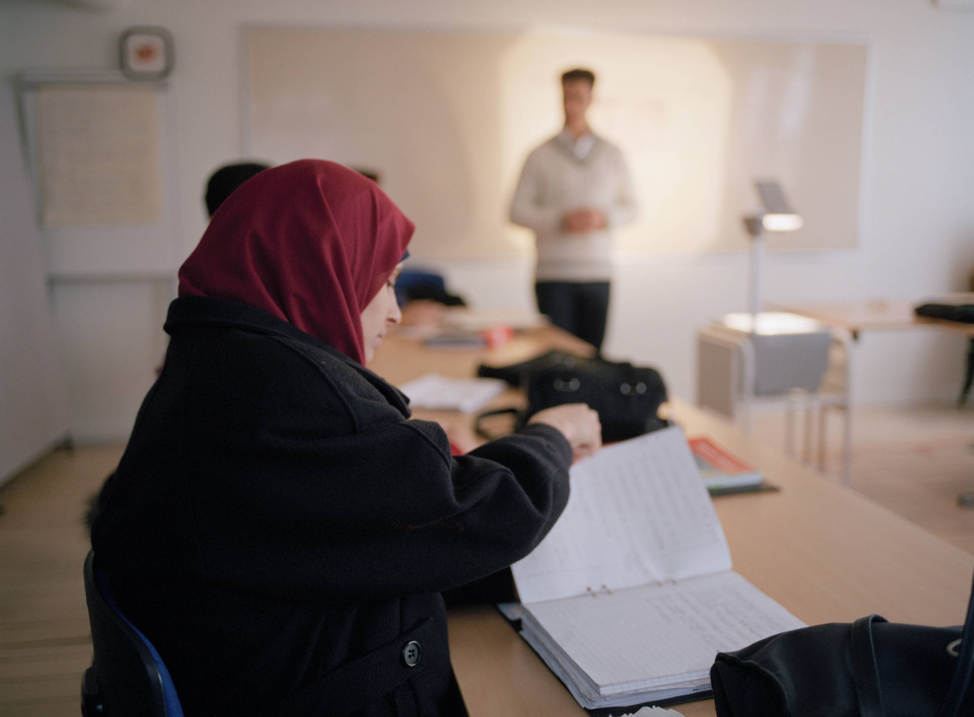

”Many new things are interesting, rewarding and amusing. I learned about contraceptives, food and how to treat a cold…”

“The IHAs are fantastic! I would like to hear the information again because I didn’t feel too well and I could not concentrate during the lecture.”

Foto: Martin Israelsson

For additional information, please contact:

Author:
Katarina Löthberg, project manager
Health Advisors in a multicultural society
A dissemination project within Equal Action III

Uppsala Kommun
Kontoret för barn, ungdom och arbetsmarknad
753 75 Uppsala,
Sweden

katarina.lothberg@uppsala.se

Tel no +46 18 727 86 59, +46 705 53 30 61

Additional information from:
Gunnar Dalbäck, Manager, Primary Health Care Centre for Asylum Seekers and
Manager of the International Health Advisors unit
Gunnar.dahlback@skane.se

Lisbeth E Rosengren, Manager Primary Health Care Centre Rosengård och Törnrosen
Lisbeth.e.rosengren@skane.se

Gunilla Håkansson, Principle, Swedish for Immigrants
Gunilla.hakansson@malmo.se

