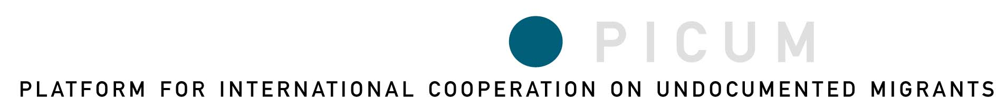

and



Undocumented Migrants Have Rights!
Workshop on Protection and Gaps Under the
International Human Rights Framework

Brussels, Friday, March 30, 2007
12:00 p.m. – 6:00 p.m.
Venue: Polygon, rue de Molenbeek, 122, 1020 Brussels (Metro: Bockstael)

All across Europe, and in different regions throughout the world, a growing number of non-governmental organizations, local authorities, professionals from diverse fields, as well as undocumented migrants uphold the principle that “no human being is illegal.” In their daily work and lives, these local actors strive to defend undocumented migrants’ human rights, including the right to health care, education and training, fair working conditions, and housing. Yet they are confronted on a daily basis with situations in which they witness that irregular status is an obstacle and a way of discriminating a sizeable part of the population in accessing basic social services and in upholding their human rights.

At the same time, the various conventions, treaties and other instruments and procedures that make up the international human rights framework specify which rights are considered “human rights” and thus applicable to all people, including those who are residing in a country irregularly (undocumented migrants) .

At this workshop, PICUM will launch a publication entitled Undocumented Migrants Have Rights! An Overview of the International Human Rights Framework. This publication outlines the various articles in the international human rights framework (as well as in European instruments on human rights) which grant protection to undocumented migrants. The publication is aimed at being a tool for local actors to strengthen their work in defending undocumented migrants’ rights.

The aim of the workshop, which is jointly organized by PICUM and Migrants Rights International (MRI), is to provide an opportunity to share experiences of how the international human rights framework is challenged by the context on the ground, one in which undocumented migrants’ human rights are systematically violated.

The working language will be English.
PROGRAM

12:00 – 1:00 Registration and lunch

1:00 – 1:15 Welcome and Introduction
Don Flynn, PICUM Chair
Cathi Tactaquin, Migrants Rights International (MRI) and National Network for Immigrant and Refugee Rights (NNIRR)

1:15 – 2:30 Presentation of PICUM’s report Undocumented Migrants Have Rights! An Overview of the International Human Rights Framework
Michele LeVoy, PICUM Director

How can a rights-based approach be used to bridge the gap between the international framework and the reality on the ground?
Examples of defending undocumented migrants’ human rights in different regions of the world:
Asia: William Gois, Regional Coordinator, Migrant Forum in Asia (MFA)
Latin America: Pablo Ceriani, Lawyer, Centro de Estudios Legales y Sociales (CELS)
North America: Cathi Tactaquin, Executive Director, National Network for Immigrant and Refugee Rights (NNIRR)
Europe: Sabine Craenen, Coordinator, Organization for Undocumented Workers (OR.C.A.)

2:30-3:45 First workshop session: Experiences of discrimination.
How are undocumented migrants discriminated when it comes to upholding their human rights, including the right to housing, fair working conditions, health care, and education, as well as other human rights? What are particular human rights violations concerning undocumented women and children?

3:45-4:00 Feedback session

4:00-4:15 Coffee break

4:15-5:30 Second workshop session: Arguments and strategies for defending rights.
What are some ways that you have used to defend undocumented migrants’ rights? How effective are some strategies in comparison to others? What are some arguments that you use to justify that undocumented migrants are not “illegal” and have rights?

5:30-5:45 Feedback session

5:45-6:00 Closure

